**WS25 - EXAM 2 UML Exercise REVIEW**

**Rubric:**

NAME: grade 8/10 -> 12/15

Q38-51

A ->

* + name /0.5
  + attributes /0.2
  + constructor /0.2
  + setters & getters /0.1

B ->

* + name /0.5
  + attribute /0.5

C ->

* + extends /0.5
  + attribute /0.2
  + constructor /0.2
  + setters & getters /0.1

D ->

* + extends /0.4
  + constructor /0.4
  + setters & getters /0.2

E ->

* + name /0.8
  + toString /0.2

F ->

* + name /0.8
  + toString /0.2

G ->

* + implements /0.5
  + method m() /0.5

H ->

* + interface and name /1.0
  + method m /1.0

J ->

* + name /0.8
  + toString /0.2

main ->

* + A a /0.4
  + ArrayList<B> bs /0.4
  + C[ ] cs = new C[3] /0.4
  + D[ ] ds = new D[4] /0.4
  + println() /0.4

**DATE: 18th january2022**

1 ALMACHE LITARDO ANDERSON MOISES 5.7/10 -> 8.5/15

Inspector: Altamirano Cristhian

Q38-51

A ->

* + name 0.5/0.5
  + attributes 0.2/0.2
  + constructor 0.2/0.2
  + setters & getters 0.1/0.1

B ->

name 0.5/0.5

attribute 0/0.5

C ->

extends 0.5/0.5

* + attribute 0.5/0.2
  + constructor 0.2/0.2
  + setters & getters 0/0.1

D->

extends 0.4/0.4

constructor 0.4/0.4

setters & getters 0.2/0.2

E->

name 0.8/0.8

to string 0.2/0.2

F->

name 0.8/0.8

to string 0.2/0.2

G->

implements 0/0.5

method m() 0/0.5

I don´t create the class G

H->

interface and name 0/1.0

method m 0/1.0

J->

1. name 0./0.8
2. to string 0/0.2

main->

A a 0/0.4

* + ArrayList<B> bs 0/0.4
  + C[ ] cs = new C[3] 0./0.4
  + D[ ] ds = new D[4] 0./0.4
  + println() 0/0.4

2 ALTAMIRANO BENALCAZAR CRISTHIAN ALEXANDER 7,4/10 → 11,1/15

Inspector: Alvarez Michelle

Q38-51

A ->

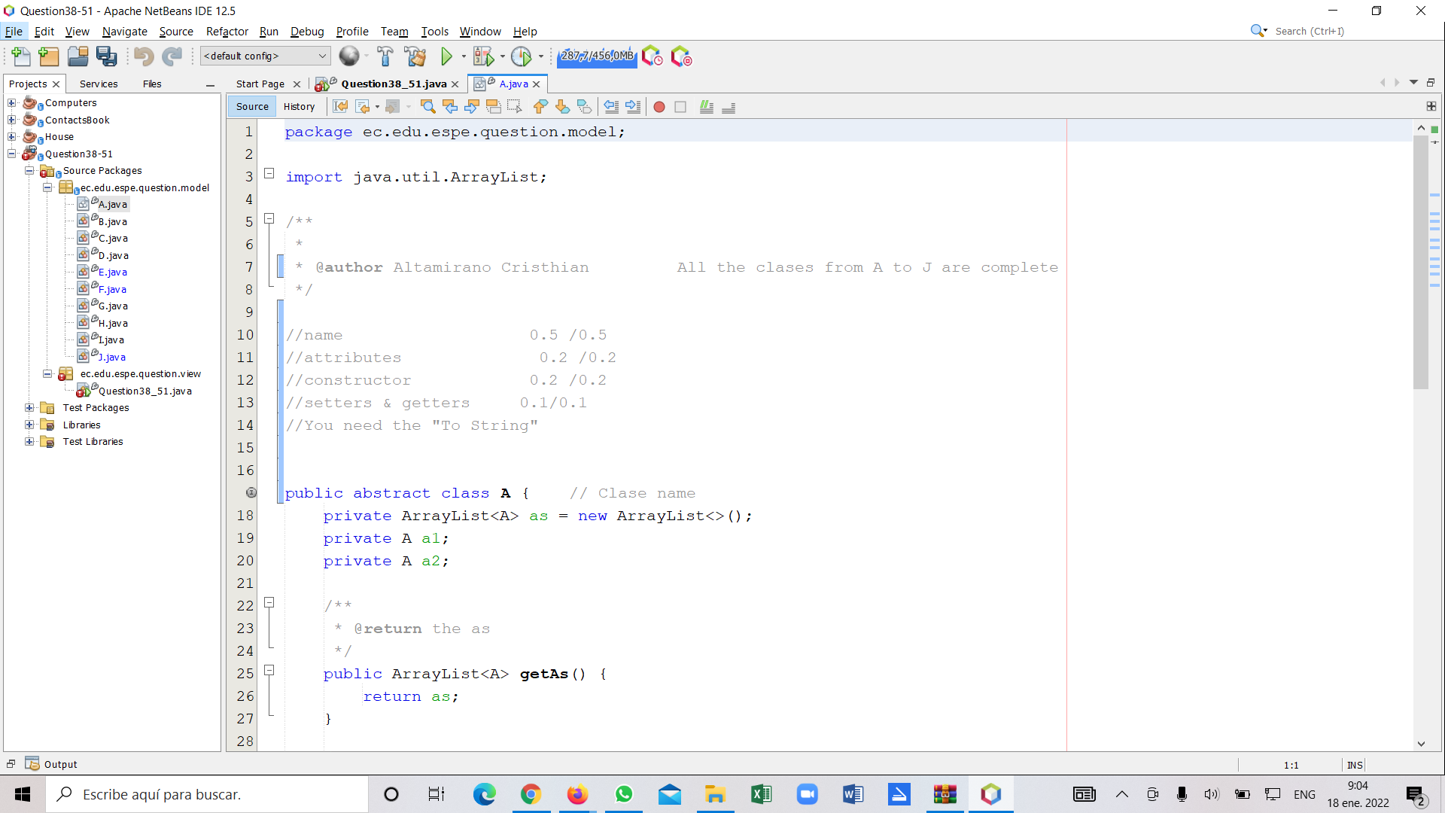

* + name 0.5/0.5
  + attributes 0.2/0.2
  + constructor 0.2/0.2
  + setters & getters 0.1/0.1

B ->

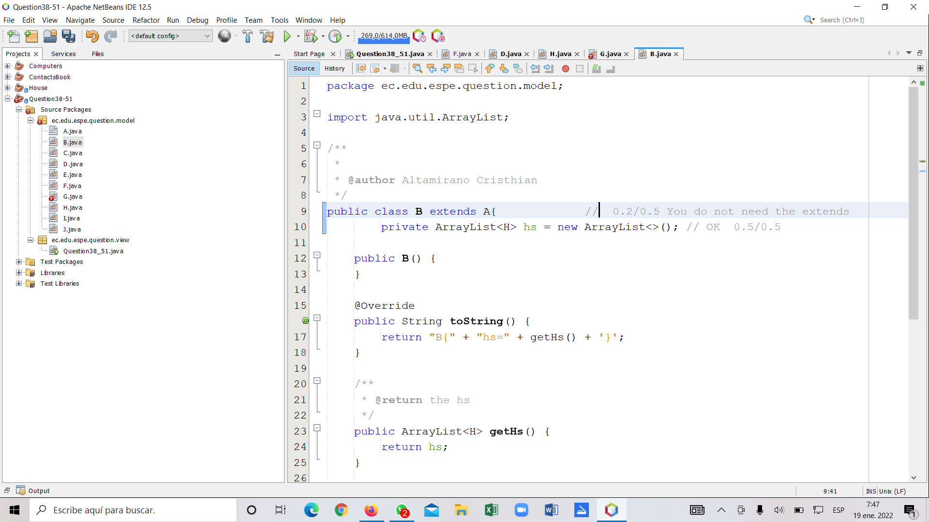

* + name 0.2/0.5
  + attribute 0.5/0.5

C ->

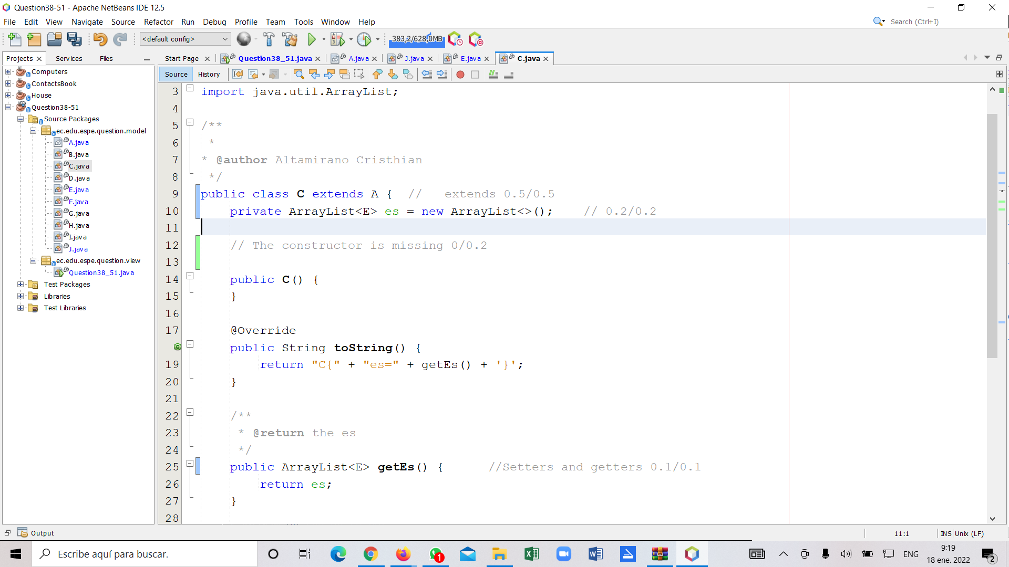

* + extends 0.5/0.5
  + attribute 0.2/0.2
  + constructor 0/0.2
  + setters & getters 0.1/0.1

D ->

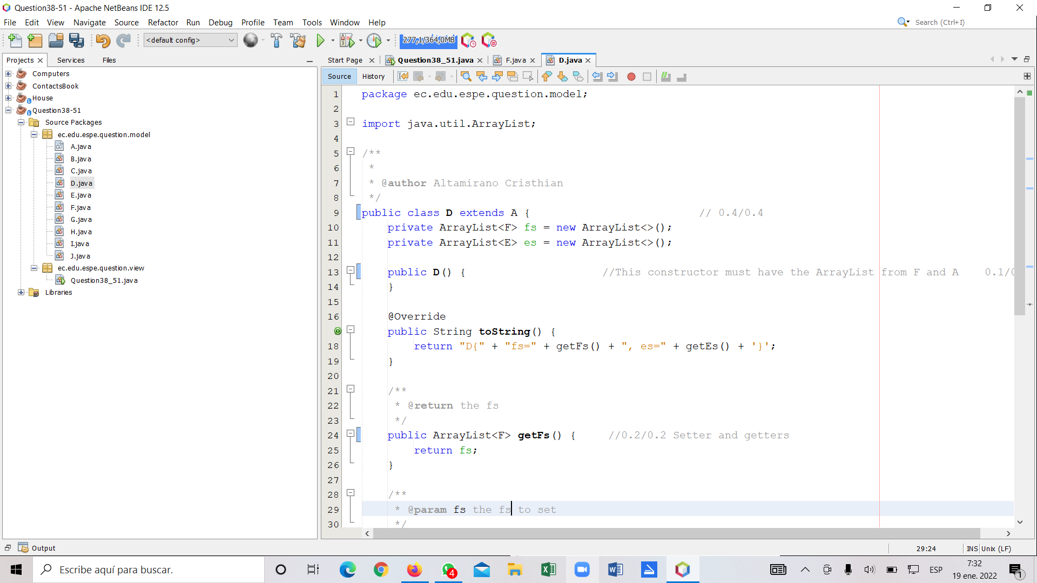

* + extends 0.4/0.4
  + constructor 0.2/0.4
  + setters & getters 0.2/0.2

E ->

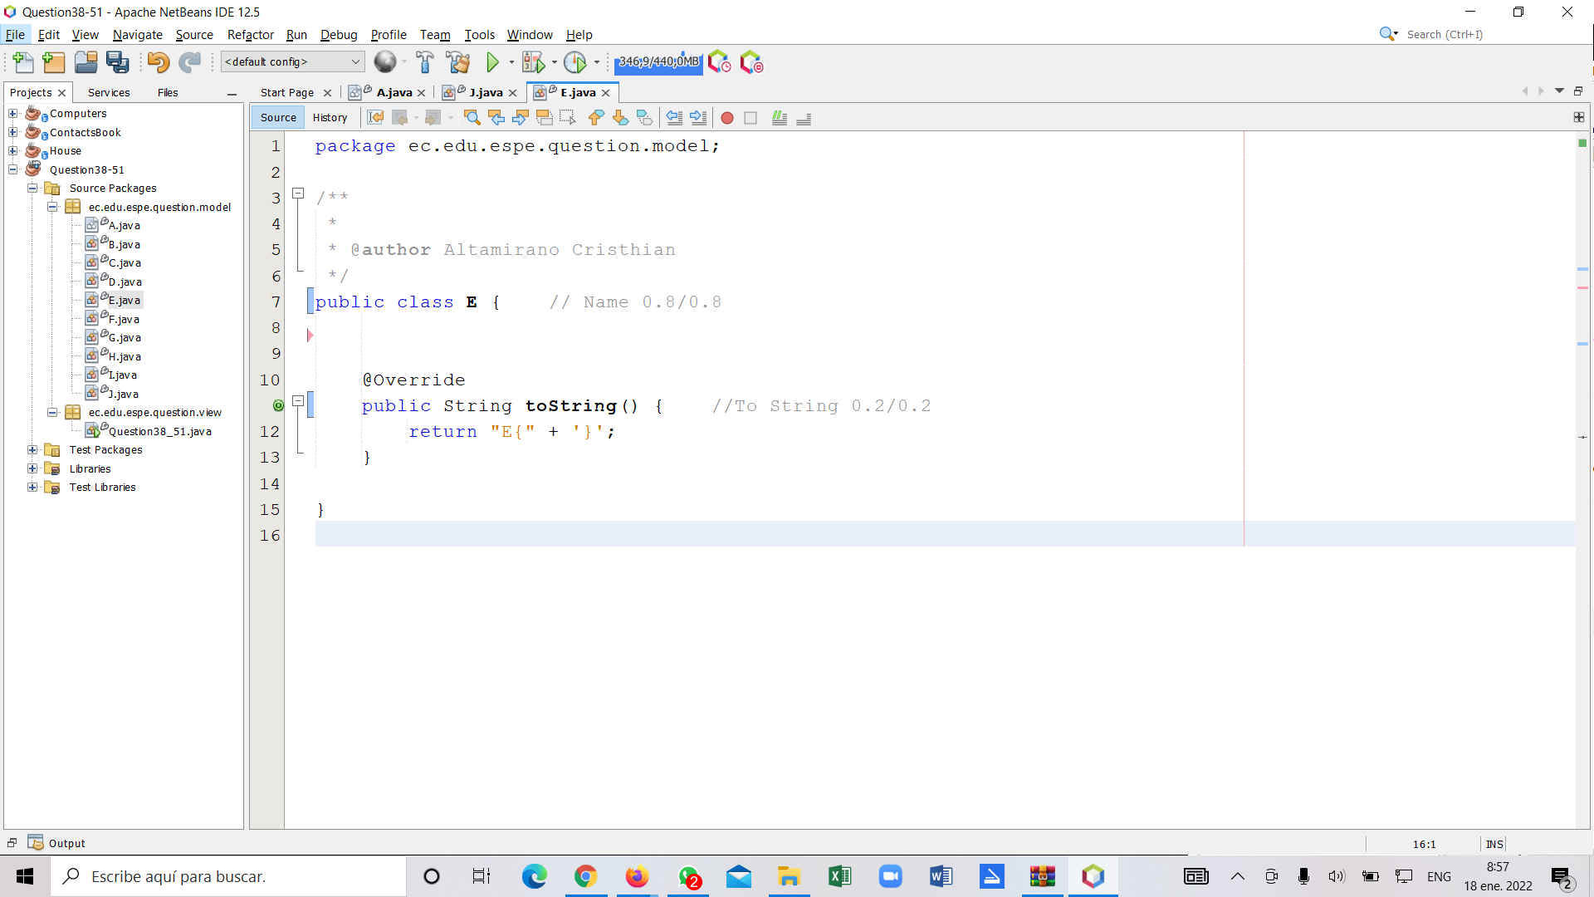

* + name 0.8/0.8
  + toString 0.2/0.2

F ->

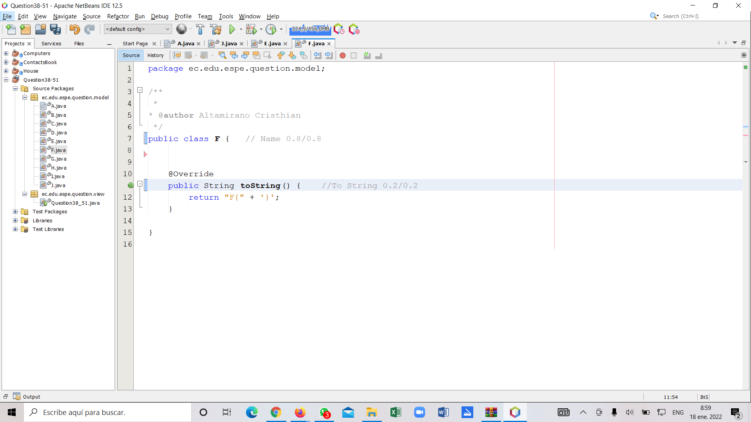

* + name 0.8/0.8
  + toString 0.2/0.2

G ->

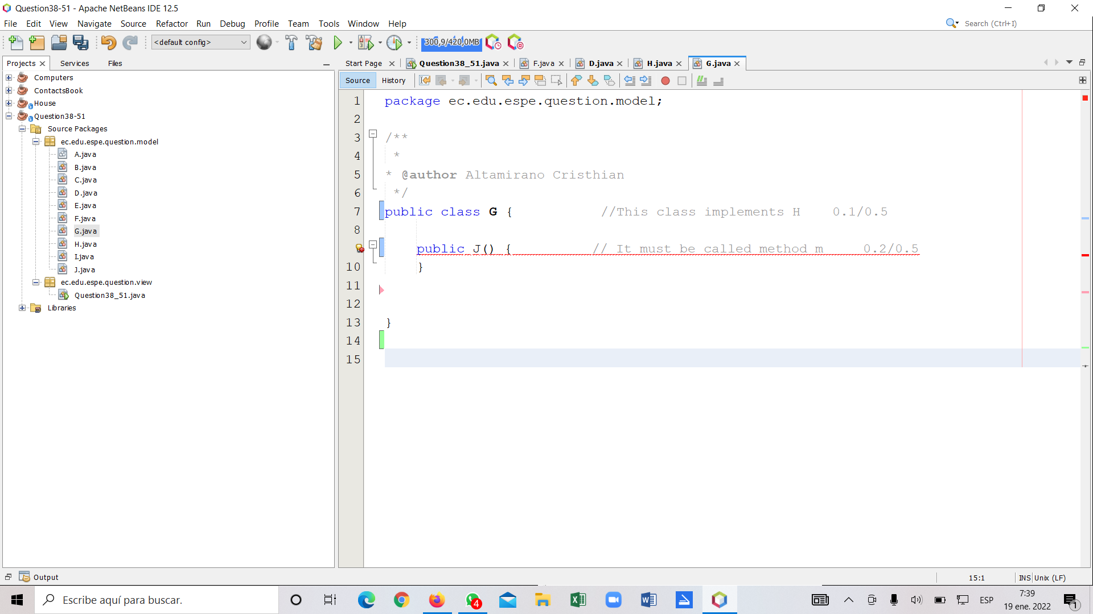

* + implements 0.1/0.5
  + method m() 0.2/0.5

H ->

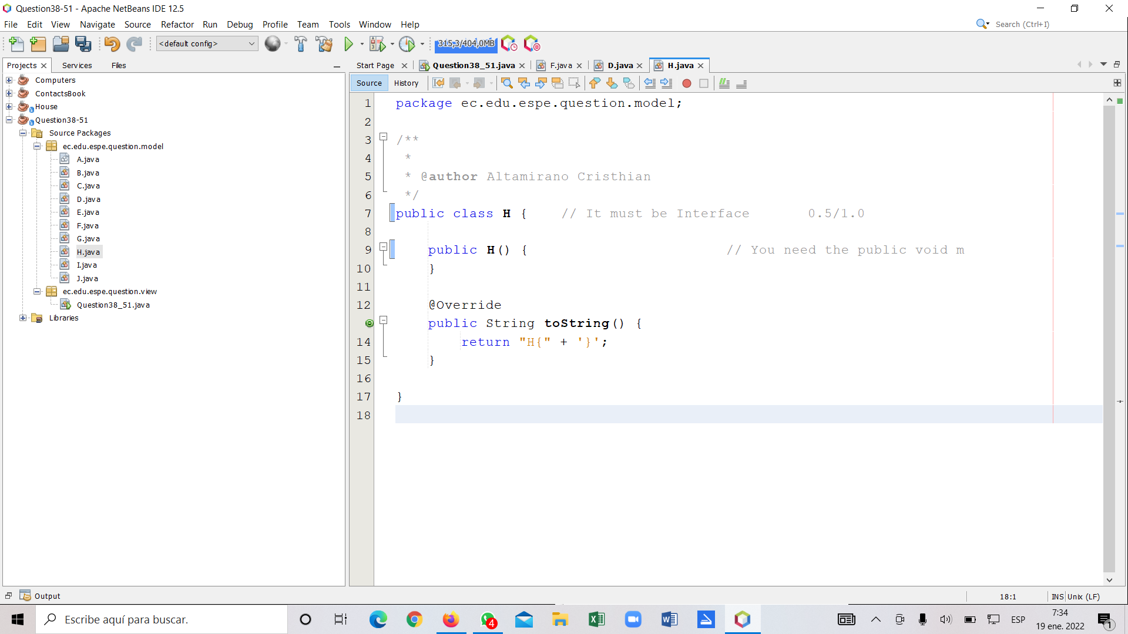

* + interface and name 0.5/1.0
  + method m 0 /1.0

J ->

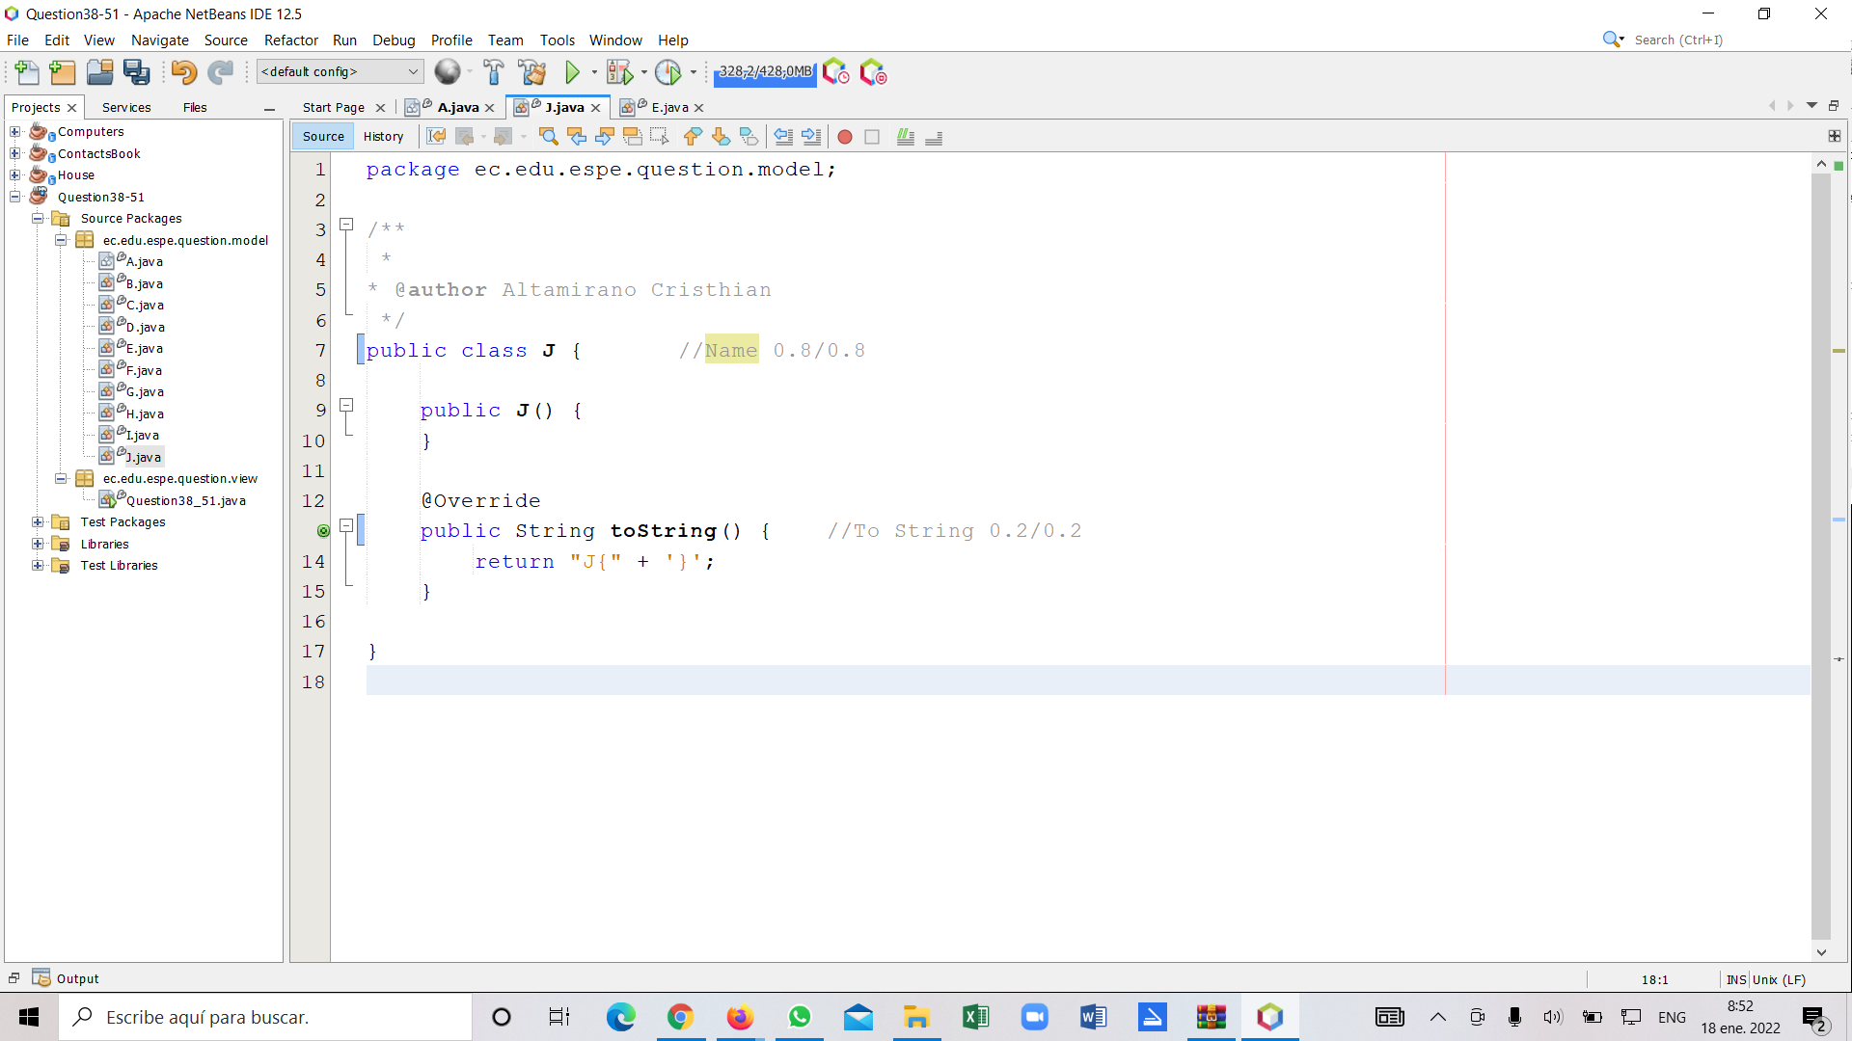

* + name 0.8/0.8
  + toString 0.2/0.2

1. main ->

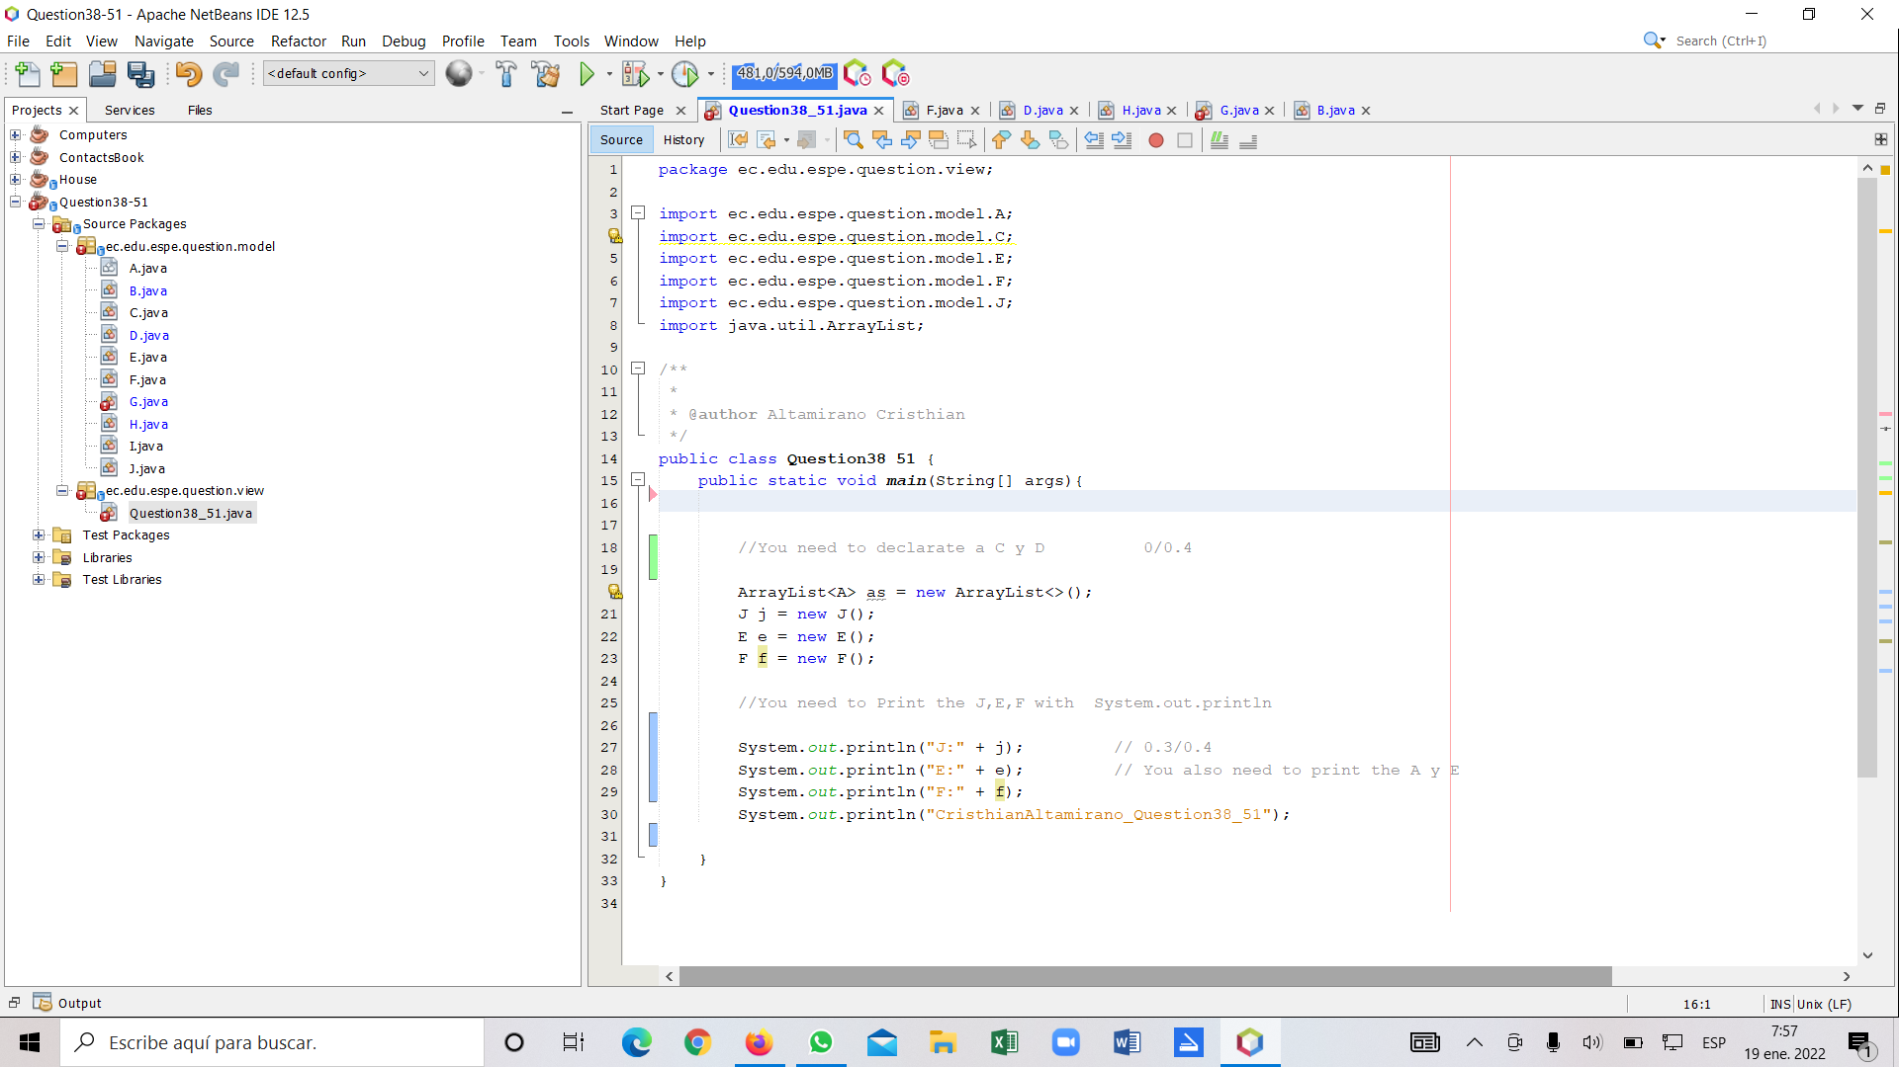

* + A a 0/0.4
  + ArrayList<B> bs 0/0.4
  + C[ ] cs = new C[3] 0/0.4
  + D[ ] ds = new D[4] 0/0.4
  + println() 0.3/0.4

3 ALVAREZ RAMIREZ MICHELLE ESTEFANIA

Inspector Andrade Alan

grade: 9,72/15 6,48/10

A ->

* + name 0.5/0.5
  + attributes 0.2/0.2
  + constructor 0.2/0.2
  + setters & getters 0.1/0.1

B ->

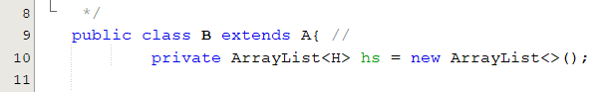

C ->

* extends 0.5/0.5
* attribute 0.2/0.2
* constructor 0.1/0.2
* setters & getters 0.1/0.1

D ->

* extends 0.4/0.4
* constructor 0.3/0.4
* setters & getters 0.2/0.2

E ->

* + name 0.8/0.8
  + toString 0.2/0.2

F ->

* + name 0.8/0.8
  + toString 0.2/0.2

G ->

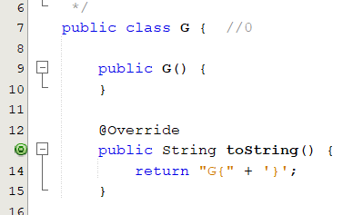

H ->

* interface and name 1.0/1.0
* method m 0/1.0

J ->

* + name 0.8/0.8
  + toString 0.2/0.2

Main->

* + A a 0/0.4
  + ArrayList<B> bs 0/0.4
  + C[ ] cs = new C[3] 0/0.4
  + D[ ] ds = new D[4] 0/0.4
  + println() 0.2/0.4

4 ANDRADE CARATE ALAN DAMIAN grade: 5.4/10 -> 8.1/15

Inspector: Andrango Alex

Q38-51

A ->

* + name 0.5/0.5
  + attributes 0.2/0.2
  + constructor 0.1/0.2
  + setters & getters 0.1/0.1

B->

* name 0.5/0.5
* attribute 0.3/0.5

C->

* extends 0.5/0.5
* attribute 0.2/0.2
* constructor 0/0.2
* setters & getters 0.1/0.1

D->

* extends 0.4/0.4
* constructor 0.3/0.4
* setters & getters 0.2/0.2

E->

* name 0.8/0.8
* toString 0.2/0.2

F->

* name 0.8/0.8
* toString 0.2/0.2

G->

* implements 0/0.5
* method m() 0/0.5

H->

* interface and name 0/1.0
* method m 0/1.0

J->

* + name 0/0.8
  + toString 0/0.2

main ->

* + A a 0/0.4
  + ArrayList<B> bs 0/0.4
  + C[ ] cs = new C[3] 0/0.4
  + D[ ] ds = new D[4] 0/0.4
  + println() 0/0.4

5 ANDRANGO ESPINOSA ALEX PAUL

Q38-51

A ->

* + name 0.5/0.5
  + attributes 0.2/0.2
  + constructor 0.0/0.2
  + setters & getters 0./0.1

B->

* name 0.5/0.5
* attribute 0/0.5

C->

* extends 0/0.5
* attribute 0/0.2
* constructor 0/0.2
* setters & getters 0/0.1

D->

* extends 0/0.4
* constructor 0/0.4
* setters & getters 0/0.2

E->

* name 0.8/0.8
* toString 0/0.2

F->

* name 0.8/0.8
* toString 0/0.2

G->

* implements 0/0.5
* method m() 0/0.5

H->

* interface and name 1/1.0
* method m 0/1.0

J->

* + name 0.8/0.8
  + toString 0/0.2

main ->

* + A a 0/0.4
  + ArrayList<B> bs 0/0.4
  + C[ ] cs = new C[3] 0/0.4
  + D[ ] ds = new D[4] 0/0.4
  + println() 0/0.4

6 ARROBA SOLORZANO CRISTIAN ALEXANDER

Inspector: Asumaza Dylan

Q38-51

nota: grade 0/10 -> 0/15

A ->

* + name 0/0.5
  + attributes 0/0.2
  + constructor 0/0.2
  + setters & getters 0/0.1

B ->

* + name 0/0.5
  + attribute 0/0.5

C ->

* + extends 0/0.5
  + attribute 0/0.2
  + constructor 0/0.2
  + setters & getters 0/0.1

D ->

* + extends 0/0.4
  + constructor 0/0.4
  + setters & getters 0/0.2

E ->

* + name 0/0.8
  + toString 0/0.2

F ->

* + name 0/0.8
  + toString 0/0.2

G ->

* + implements 0/0.5
  + method m() 0/0.5

H ->

* + interface and name 0/1.0
  + method m 0/1.0

J ->

* + name 0/0.8
  + toString 0/0.2

main ->

* + A a 0/0.4
  + ArrayList<B> bs 0/0.4
  + C[ ] cs = new C[3] 0/0.4
  + D[ ] ds = new D[4] 0/0.4
  + println() 0/0.4

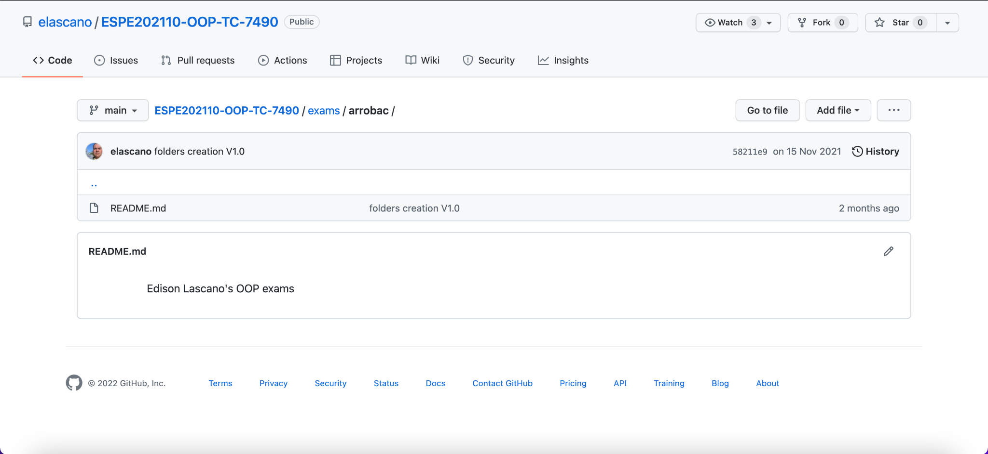

Observation:There is nothing uploaded to github

7 ASUMAZA GUALOTO DYLAN ALEXANDER

Inspector: Bravo Katherin

nota: grade 6,5/10 -> 9.50/15

Q38-51

A ->

* + name 0.5/0.5
  + attributes 0,2/0.2
  + constructor 0,2/0.2
  + setters & getters 0.1/0.1

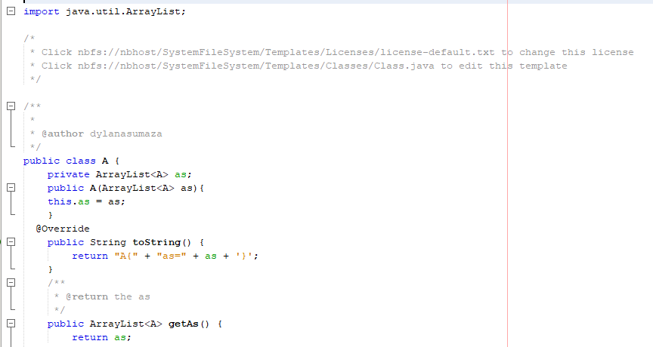

B ->

* + name 0.5/0.5
  + attribute 0.5/0.5

C ->

* + extends 0.4/0.5
  + attribute 0.2/0.2
  + constructor 0.1/0.2
  + setters & getters 0.1/0.1

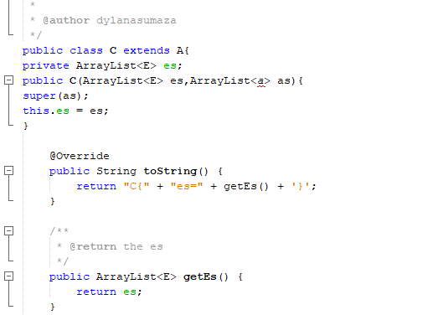

D ->

* + extends 0.3/0.4
  + constructor 0.2/0.4
  + setters & getters 0.2/0.2

E ->

* + name 0.7/0.8
  + toString 0.1/0.2

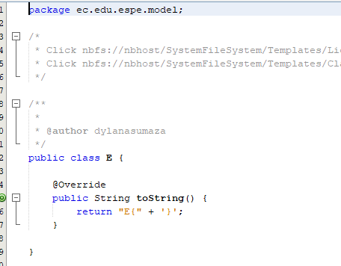

F ->

* + name 0.8/0.8
  + toString 0.2/0.2

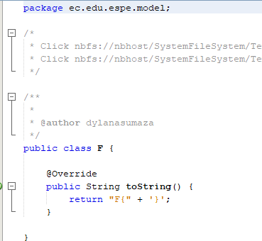

G ->

* + implements 0.4/0.5
  + method m() 0.3/0.5

H ->

* + interface and name 0.5/1.0
  + method m 0.5/1.0

J ->

* + name 0.8/0.8
  + toString 0/0.2

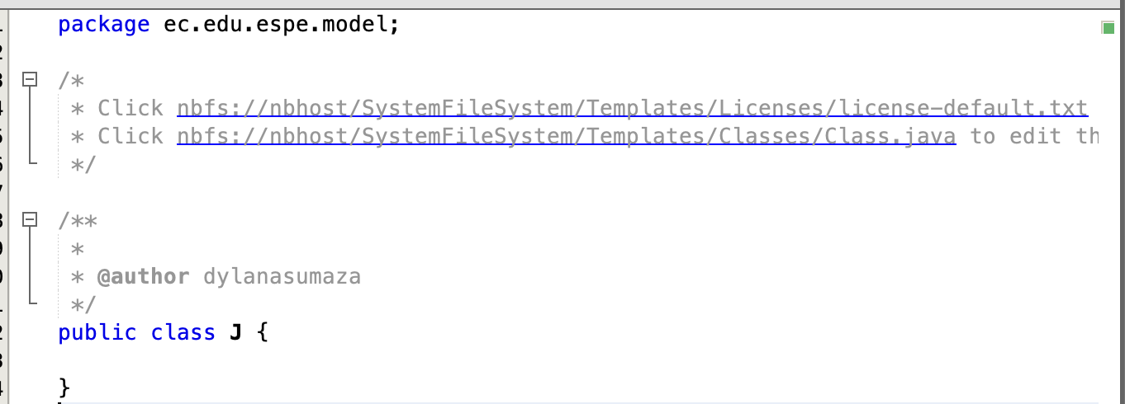

main ->

* + A a 0.2/0.4
  + ArrayList<B> bs 0.4/0.4
  + C[ ] cs = new C[3] 0.2/0.4
  + D[ ] ds = new D[4] 0.3/0.4
  + println() 0.1/0.4

8 BRAVO RODRIGUEZ KATHERIN DAYANNE

Inspector: Bravo Christian

nota: grade 7/10 -> 10/15

Q38-51

A ->

* + name 0.5/0.5
  + attributes 0.2/0.2
  + constructor 0.2/0.2
  + setters & getters 0.1/0.1

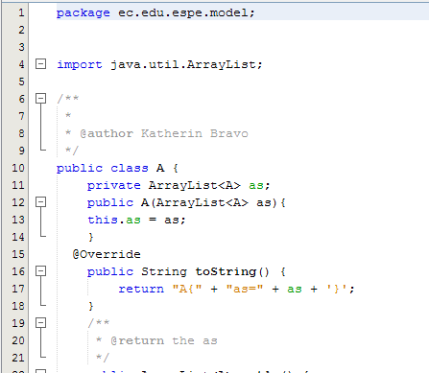

B ->

C ->

* + extends 0.4/0.5
  + attribute 0.2/0.2
  + constructor 0.1/0.2
  + setters & getters 0.1/0.1

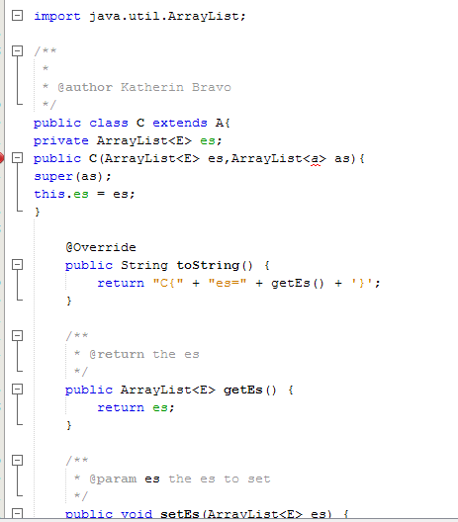

D ->

E ->

* + name 0.7/0.8
  + toString 0.1/0.2

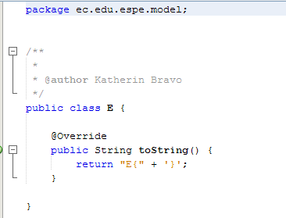

F ->

* + name 0.8/0.8
  + toString 0.2/0.2

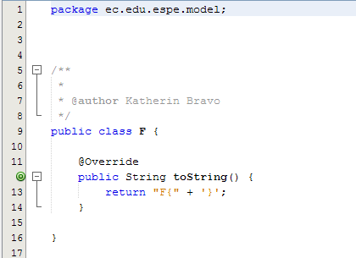

G ->

H ->

J ->

* + name 0.6/0.8
  + toString 0.2/0.2

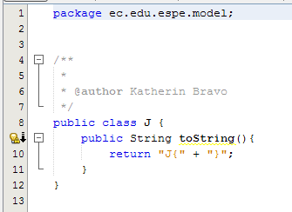

main ->

* + A a 0.2/0.4
  + ArrayList<B> bs 0.4/0.4
  + C[ ] cs = new C[3] 0.2/0.4
  + D[ ] ds = new D[4] 0.1/0.4
  + println() 0.1/0.4

TOTAL:7

9 BRAVO VILLALOBOS CHRISTIAN DAVID

Inspector: Pablo Bustillos

Q38-51

Nota: 5.5/10 8.25/15

A ->

* + name 0.5/0.5
  + attributes 0.2/0.2
  + constructor 0.2/0.2
  + setters & getters 0.1/0.1

B ->0

C ->

* + extends 0.5/0.5
  + attribute 0.2/0.2
  + constructor 0.2/0.2
  + setters & getters 0.1/0.1

D ->

extends 0/0.4

* + constructor 0/0.4
  + setters & getters 0/0.2

E ->

* + name 0.8/0.8
  + toString 0.2/0.2

F ->

* + name 0.8/0.8
  + toString 0.2/0.2

G ->0

H ->0

J ->0

* + name 0.8/0.8
  + toString 0.2/0.2

main ->

A a 0.4/0.4

* + ArrayList<B> bs 0/0.4
  + C[ ] cs = new C[3] 0/0.4
  + D[ ] ds = new D[4] 0/0.4
  + println() 0.1/0.4

10 BUSTILLOS MONTENEGRO PABLO SEBASTIAN

Inspector: Benjamin Cadena

Nota : 7.6/10 —-- 11.5./15

Q38-51

A ->

* + name 0.5/0.5
  + attributes 0.2/0.2
  + constructor 0.2/0.2
  + setters & getters 0.1/0.1

B ->

* + name 0.5/0.5
  + attribute 0/0.5

C ->

* + extends 0.5/0.5
  + attribute 0.2/0.2
  + constructor 0.2/0.2
  + setters & getters 0.1/0.1

D ->

* + extends 0.4/0.4
  + constructor 0.4/0.4
  + setters & getters 0.2/0.2

E ->

* + name 0.8/0.8
  + toString 0.2/0.2

F ->

* + name 0.8/0.8
  + toString 0.2/0.2

G ->

* + implements 0.5/0.5
  + method m() 0/0.5

H ->

* + interface and name 0.5/1.0
  + method m 0/1.0

J ->

* + name 0.8/0.8
  + toString 0.2/0.2

main ->

A a 0.4/0.4

* + ArrayList<B> bs 0.4/0.4
  + C[ ] cs = new C[3] 0/0.4
  + D[ ] ds = new D[4] 0/0.4
  + println() 0.1/0.4

11 CADENA ROMAN BENJAMIN ABEL Total: 6.1/10 - 9.15/15

Inspector: Sebastián Caisatoa

Q38-51

A ->

name 0.5/0.5

attributes 0.2/0.2

constructor 0/0.2

setters & getters 0/0.1

B ->

name 0.5/0.5

attribute 0/0.5

C ->

name 0.5/0.5

attributes 0/0.2

constructor 0/0.2

setter & getters 0/0.2

D ->

extends 0.4/0.4

constructor 0/0.4

setters & getters 0/0.1

E ->

name 0.8/0.8

toString 0/0.2

F ->

name 0.5/0.5

toString 0/0.2

G ->

implements 0.5/0.5

method m() 0/0.5

H ->

interface and name 1.0/1.0

method extra 0/1.0

J ->

name 0.8/0.8

attributes 0/0.2

main ->

A a 0.4/0.4

ArrayList<B> bs 0/0.4

C[ ] cs = new C[3] 0/0.4

D[ ] ds = new D[4] 0/0.4

println() 0/0.4

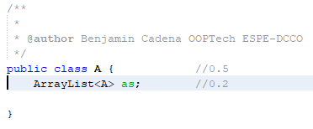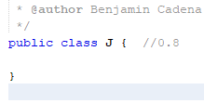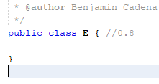

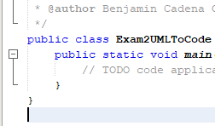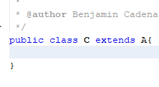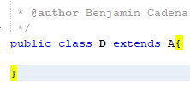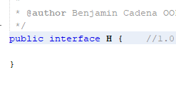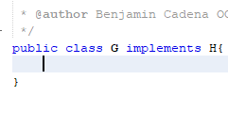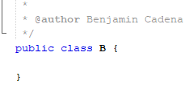

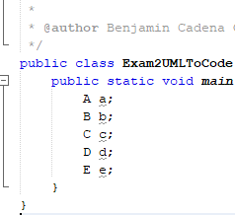

12 CAISATOA RAMIREZ SEBASTIAN BERNARDO (Total: 6,7/10 - 10.05/15)

Inspector: Andy Josue Calderon Merchan

Q38-51

A ->

* + name 0.5/0.5
  + attributes 0.2/0.2
  + constructor 0.1/0.2
  + setters & getters 0/0.1

1. B -> name 0.5/0.5

method 0/0.5

1. C ->

name 0.5/0.5

attributes 0.2/0.2

constructor 0/0.2

setters & getters 0/0.1

1. D ->

name 0.4/0.4

constructor 0/0.4

setters & getters 0/0.2

1. E ->

name 0.8/0.8

toString 0/0.2

1. F ->

name 0.8/0.8

toString 0/0.2

1. G ->

implements 0.5/0.5

method m() 0/0.5

1. H ->

interface and name 1.0/1.0

method extra 0/1.0

1. J ->
   * name 0.8/0.8
   * toString 0/0.2
2. main -> 0.4/2.0

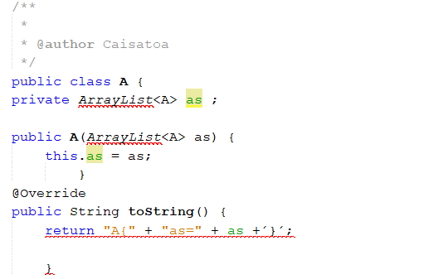

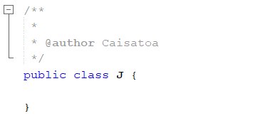

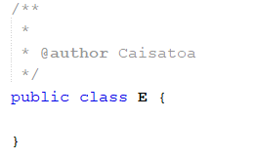

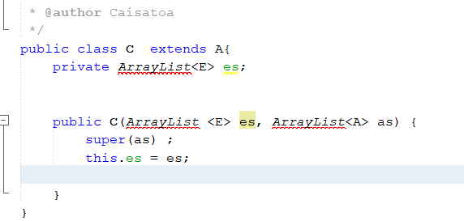

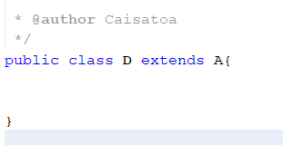

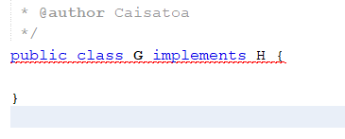

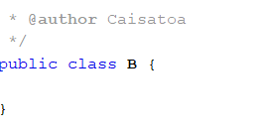

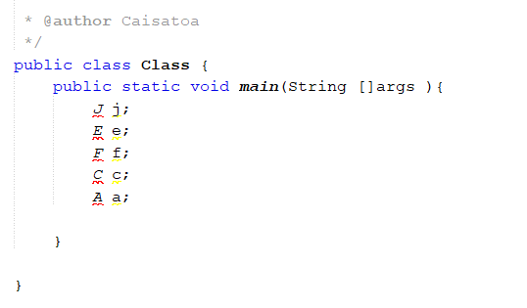

13 CALDERON MERCHAN ANDY JOSUE (grade:6.9/10 -> 10.35/15)

Inspector: Kerly Yadira Correa

A ->

* + name 0.5/0.5
  + attributes 0.1/0.2
  + constructor 0/0.2
  + setters & getters 0/0.1

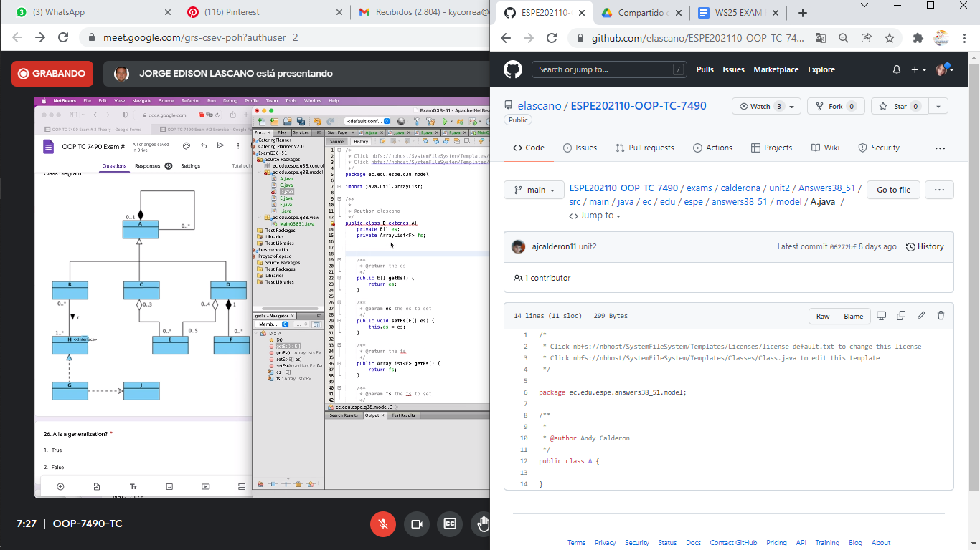

B ->

* name 0.5/0.5
* methods 0/0.5

C ->

* + name 0.3/0.5
  + attributes 0.1/0.2
  + constructor 0/0.2
  + setter & getter 0.1/0.1

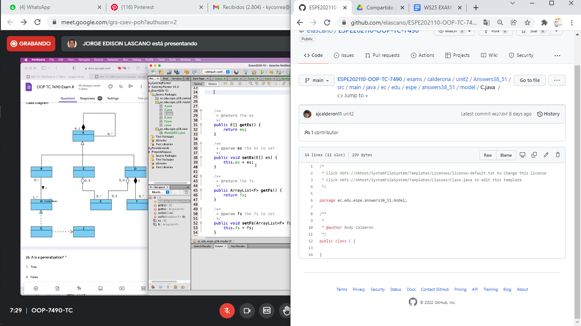

D->

* + name 0.3/0.4
  + constructor 0/0.4
  + setter & getter 0.1/0.2

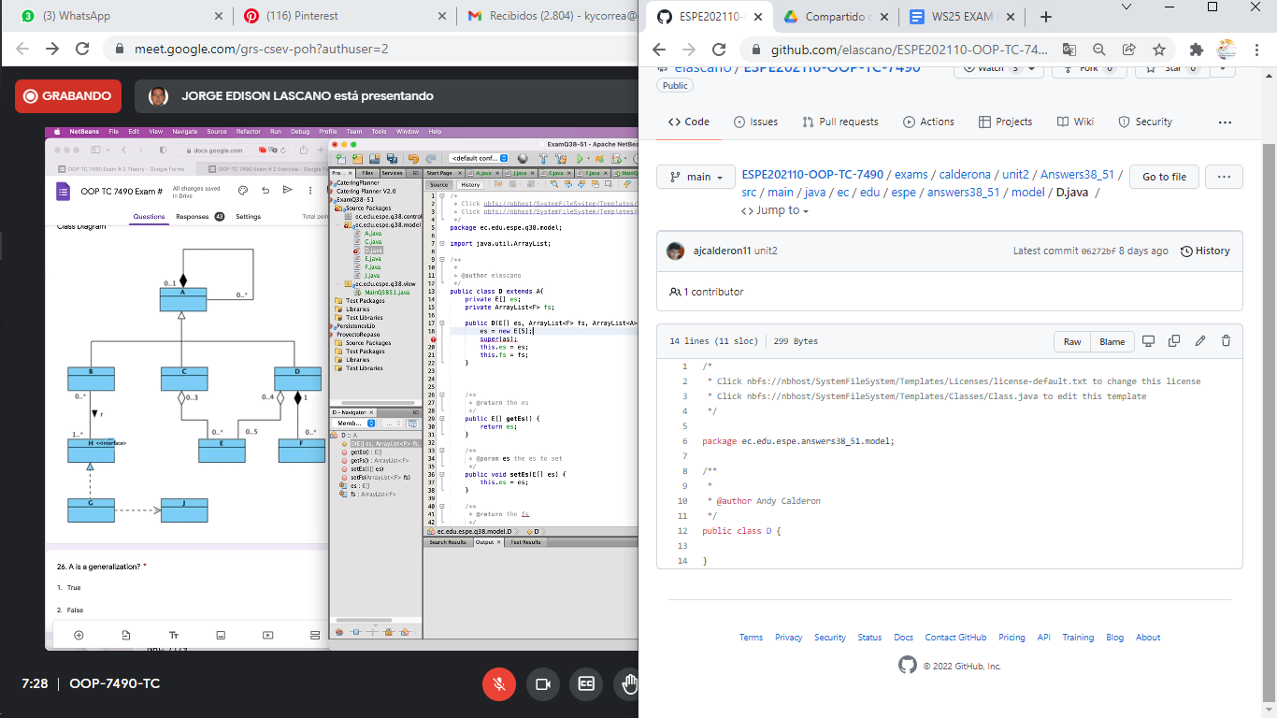

E->

* + name 0.8/0.8
  + attributes 0/0.2

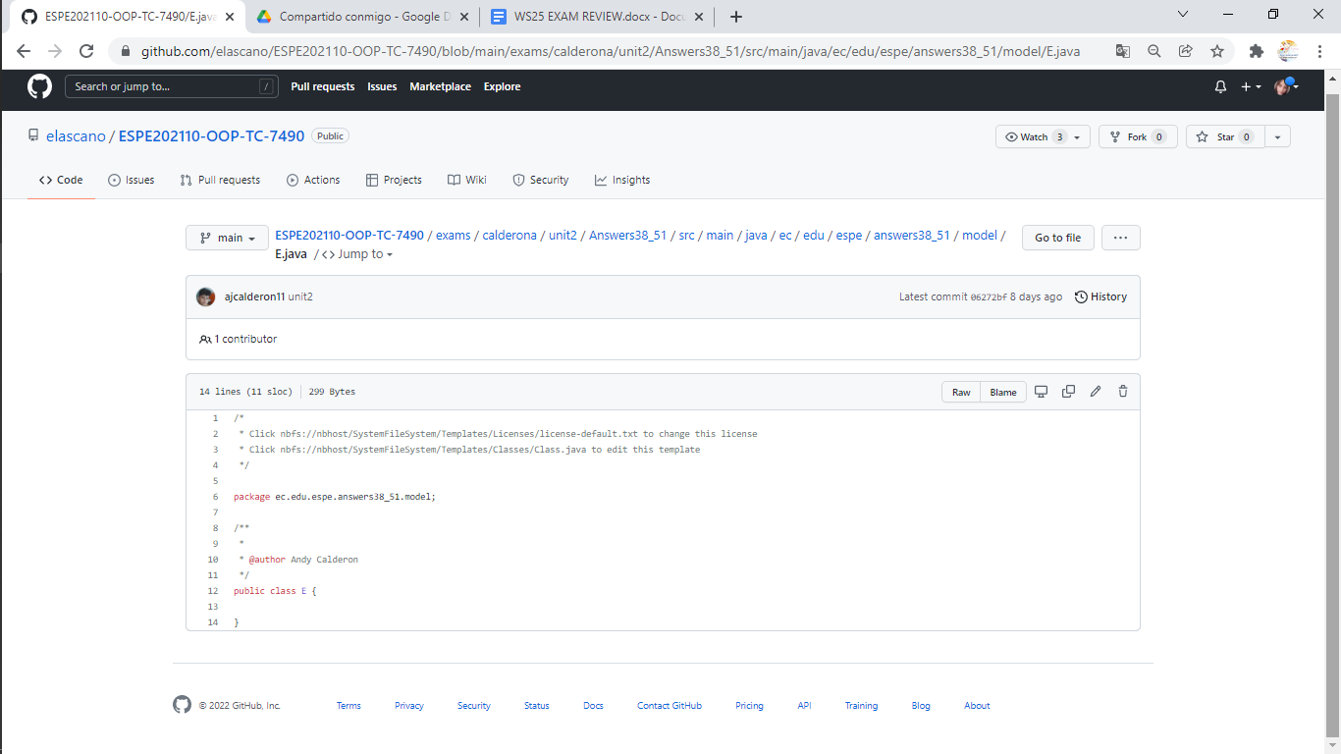

F->

* + name 0.8/0.8
  + attributes 0/0.2

G->

* name 0.5/0.5
* method m 0/0.5

H->

* + name 1.0/1.0

J ->

* + name 0.8/0.8
  + to String 0/0.2

Main-> 1/2

14 CORREA RUIZ KERLY YADIRA: grade 8.40/10 -> 12.6/15

Inspector : Darling Cruz

Q38-51

A ->

* + name 0.5/0.5
  + attributes 0.2/0.2
  + constructor 0.1/0.2
  + setters & getters 0/0.1

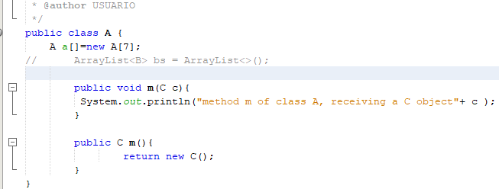

B ->

* + name 0.5/0.5
  + attribute 0/0.5

C ->

* + name 0.5/0.5
  + attributes 0/0.2
  + constructor 0/0.2
  + setters & getters 0/0.1

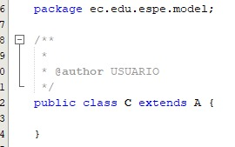

D ->

* + extends 0.4/0.4
  + constructor 0/0.4
  + setters & getters 0.2/0.2

E ->

* + name 0.8/0.8
  + attributes 0/0.2

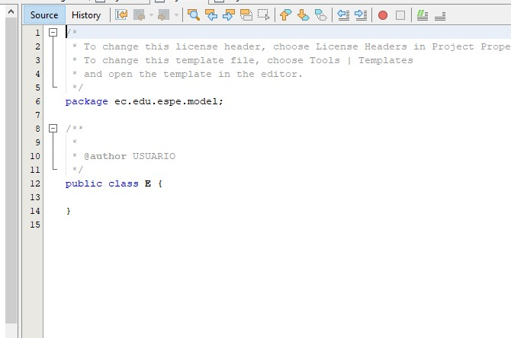

F ->

* + name 0.8 /0.8
  + to String 0 /0.2

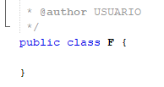

G ->

* + implements 0.5/0.5
  + method m() 0.5/0.5

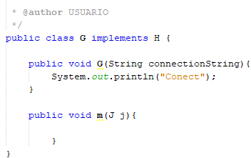

H ->

* + interface and name 1.0/1.0
  + method m 1.0/1.0

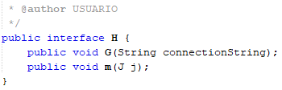

J ->

* + name 0.8/0.8
  + to String 0.2/0.2

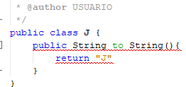

main ->

* + A a 0.4/0.4
  + ArrayList<B> bs 0/0.4
  + C[ ] cs = new C[3] 0/0.4
  + D[ ] ds = new D[4] 0/0.4
  + println() 0/0.4

total 0.4

15 CRUZ PANTOJA DARLING MICAELA

Inspector: Alejandro Delacruz

A ->

* + name 0.5/0.5
  + attributes 0.2/0.2
  + constructor 0.1/0.2
  + setters & getters 0/0.1

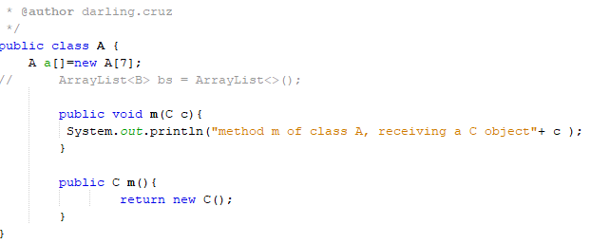

B ->

* + name 0.5/0.5
  + attribute 0.5/0.5

C ->

* + name 0.5/0.5
  + attributes 0.2/0.2
  + constructor 0/0.2
  + setters & getters 0/0.1

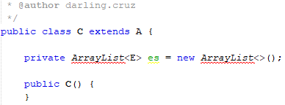

D ->

* + extends 0.4/0.4
  + constructor 0.4/0.4
  + setters & getters 0/0.2

E ->

* + name 0.8/0.8
  + attributes 0.2/0.2

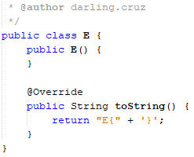

F ->

* + name 0.8 /0.8
  + to String 0.2/0.2

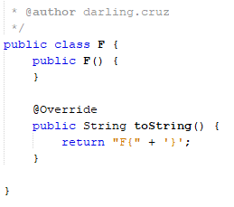

G ->

* + implements 0.5/0.5
  + method m() 0.5/0.5

H ->

* + interface and name 1,0/1.0
  + method m 1,0/1.0

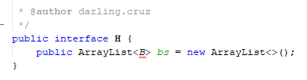

J ->

* + name 0.8/0.8
  + to String 0.2/0.2

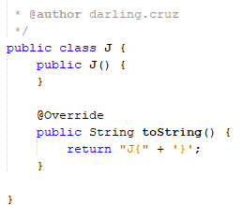

main ->

* + A a 0.4/0.4
  + ArrayList<B> bs 0.4/0.4
  + C[ ] cs = new C[3] 0/0.4
  + D[ ] ds = new D[4] 0/0.4
  + println() 0/0.4

Total 0.8

Total: 7.6/10 -> 11.4/15

16 DE LA CRUZ QUINGA ALEJANDRO SEBASTIAN

Inspector Jaime evar

A ->

* + name 0.5/0.5
  + attributes 0.2/0.2
  + constructor 0.2/0.2
  + setters & getters 0.1/0.1

B ->name 0.5/0.5

* + attribute 0/0.5

C ->

* + extends 0.5/0.5
  + attribute 0.2/0.2
  + constructor 0/0.2
  + setters & getters 0.1/0.1

D ->

* + extends 0.4/0.4
  + constructor 1/0.4
  + setters & getters 0.2/0.2

E ->

* + name 0.8/0.8
  + toString 0.2/0.2

F ->

* + name 0.8/0.8
  + toString 0.2/0.2

G ->

* + implements 0/0.5
  + method m() 1/0.5

H ->

* + interface and name 1/1.0
  + method m 1/1.0

J ->

* + name 0.8/0.8
  + toString 0.2/0.2

main ->

* + A a 0.4/0.4
  + ArrayList<B> bs 0/0.4
  + C[ ] cs = new C[3] 0/0.4
  + D[ ] ds = new D[4] 0/0.4
  + println() 0.4/0.4

Total → 8.8 -> 12.5

17 EIVAR DAGUA JAIME MAURICIO Total: 6,3/10 ->9.45/15

inspector Mayerly Garcia

Q38-51

A ->

* + name 0.5/0.5
  + attributes 0.2/0.2
  + constructor 0.2/0.2
  + setters & getters 0.1/0.1

B->

name 0.2/0.5

* + attribute 0.4/0.5

C ->

* + extends 0.5/0.5
  + attribute 0.2/0.2
  + constructor 0.2/0.2
  + setters & getters 0.1/0.1

D ->

* + extends 0.4/0.4
  + constructor 0/0.4
  + setters & getters 0.2/0.2

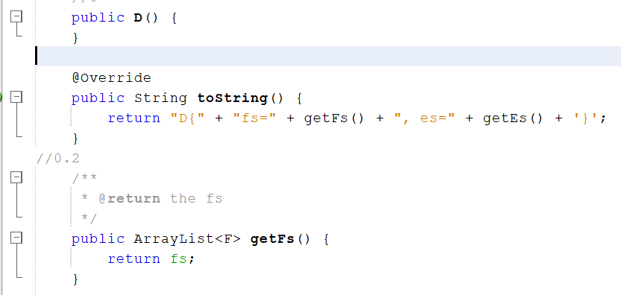

E ->

* + name 0.8/0.8
  + toString 0.2/0.2

F ->

* + name 0.8/0.8
  + toString 0.2/0.2

G ->

* + implements 0.1/0.5
  + method m() 0/0.5

H ->

* + interface and name 0/1.0
  + method m 0/1.0



J ->

* + name 0.8/0.8
  + toString 0.2/0.2

main ->

* + A a 0/0.4
  + ArrayList<B> bs 0/0.4
  + C[ ] cs = new C[3] 0/0.4
  + D[ ] ds = new D[4] 0/0.4
  + println() 0/0.4



18 GARCIA BARRETO MAYERLY PRISSILLA

inspector: Melissa Gómez

A ->

* + name 0.5/0.5
  + attributes 0.2/0.2
  + constructor 0.2/0.2
  + setters & getters 0.1/0.1

B ->

* + name 0.5/0.5
  + attribute 0.5/0.5

C ->

* + extends 0.5/0.5
  + attribute 0.2/0.2
  + constructor 0/0.2
  + setters & getters 0.1/0.1

D ->

* + extends 0.4/0.4
  + constructor 0/0.4
  + setters & getters 0.2/0.2

E ->

name 0.8/0.8

toString 0.2/0.2

F ->

name 0.8/0.8

toString 0.2/0.2

G ->

* + implements 0/0.5
  + method m() 0/0.5

H ->

* + interface and name 0/1.0
  + method m 0/1.0

J ->

* + name 0.8/0.8
  + toString 0.2/0.2

main ->

* + A a 0/0.4
  + ArrayList<B> bs 0/0.4
  + C[ ] cs = new C[3] 0/0.4
  + D[ ] ds = new D[4] 0/0.4
  + println() 0/0.4

total: 6.2=9.3/15

19 GOMEZ DIAZ MELISSA MALAYCA  
Q38-51

A ->

* + name 0.5/0.5
  + attributes 0.2/0.2
  + constructor 0.2/0.2
  + setters & getters 0.1/0.1

B ->name 0.5/0.5

* + attribute 0/0.5

C ->

* + extends 0.5/0.5
  + attribute 0.2/0.2
  + constructor 0/0.2
  + setters & getters 0.1/0.1

D ->

* + extends 0.4/0.4
  + constructor 0/0.4
  + setters & getters 0.2/0.2

E ->

* + name 0.8/0.8
  + toString 0.2/0.2

F ->

* + name 0.8/0.8
  + toString 0.2/0.2

G ->

* + implements 0/0.5
  + method m() 0/0.5

H ->

* + interface and name 1/1.0
  + method m /1.0

J ->

* + name 0.8/0.8
  + toString 0.2/0.2

main ->

* + A a 0.2/0.4
  + ArrayList<B> bs 0/0.4
  + C[ ] cs = new C[3] 0/0.4
  + D[ ] ds = new D[4] 0/0.4
  + println() 0.4/0.4

Total → 7.7→ 11.50/15

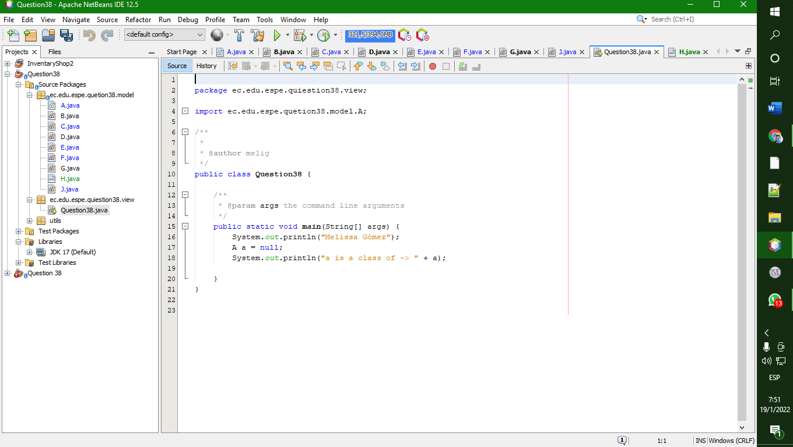

Inspector: Angel Guaman

20 GUAMAN VEJARANO ANGEL DAVID total -> 7,4/10 11,1/15

Inspector: Guitarra Jhon

Q38-51

A ->

* + name 0.5/0.5
  + attributes 0.2/0.2
  + constructor 0.2/0.2
  + setters & getters 0.1/0.1

B ->

* + name 0.5/0.5
  + attribute 0.5/0.5

C ->

* + extends 0.5/0.5
  + attribute 0.1/0.2
  + constructor 0.2/0.2
  + setters & getters 0.1/0.1

D ->

* + extends 0.1/0.4

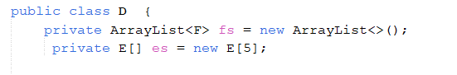

* + constructor 0.4/0.4
  + setters & getters 0.2/0.2

E ->

* + name 0.8/0.8
  + toString 0.2/0.2

F ->

* + name 0.8/0.8
  + toString 0.2/0.2

G ->

* + implements 0.1/0.5
  + method m() 0/0.5

H ->

* + interface and name 0.1/1.0
  + method m 0/1.0

J ->

* + name 0.8/0.8
  + toString 0.2/0.2

main ->

* + A a 0/0.4
  + ArrayList<B> bs 0.4/0.4
  + C[ ] cs = new C[3] 0/0.4
  + D[ ] ds = new D[4] 0/0.4
  + println() 0.2/0.4

21 GUITARRA SANCHEZ JHON ALEXANDER

Inspector: Guzman Jose

Q38-51

A ->

* + name 0.5/0.5
  + attributes 0.2/0.2
  + constructor 0.1/0.2
  + setters & getters 0.1/0.1

B ->

* + name 0.5/0.5
  + attribute 0/0.5

C ->

* + extends 0.5/0.5
  + attribute 0/0.2
  + 
  + constructor 0.0/0.2



* + setters & getters 0.1/0.1

D ->

* + extends 0.4/0.4
  + constructor 0.2/0.4
  + setters & getters 0.2/0.2

E ->

* + name 0.8/0.8
  + toString 0.2/0.2

F ->

* + name 0.8/0.8
  + toString 0.2/0.2

G ->

* + implements 0/0.5
  + method m() 0/0.5

H ->

* + interface and name 0/1.0
  + method m 0/1.0

J ->

* + name 0.8/0.8
  + toString 0.2/0.2

main ->

* + A a 0/0.4
  + ArrayList<B> bs 0/0.4
  + C[ ] cs = new C[3] 0/0.4
  + D[ ] ds = new D[4] 0/0.4
  + println() 0.4/0.4

Total -> 6.5/10 9.75/15

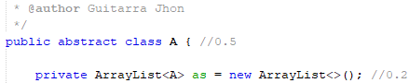

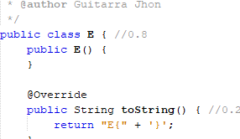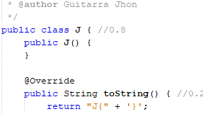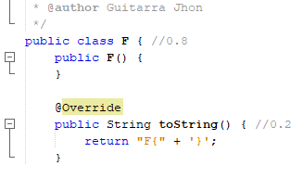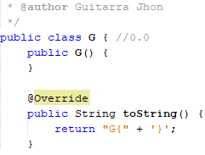

22 GUZMAN LOPEZ JOSE DAVID

Inspector: Jonathan Insuasti

A ->

* + name 0.5/0.5
  + attributes 0.1/0.2
  + constructor 0.1/0.2
  + setters & getters 0.1/0.1

B ->name 0.5/0.5

* + attribute 0-5/0.5

C -> extends 0/0.5

* + attribute 0/0.2
  + constructor 0/0.2
  + setters & getters 0/0.1

D -> extends 0/0.4

* + constructor 0/0.4
  + setters & getters 0/0.2

E ->

name 0.8/0.8

toString 0/0.2

F -> name 0.8/0.8

* + toString 0.2/0.2
  + 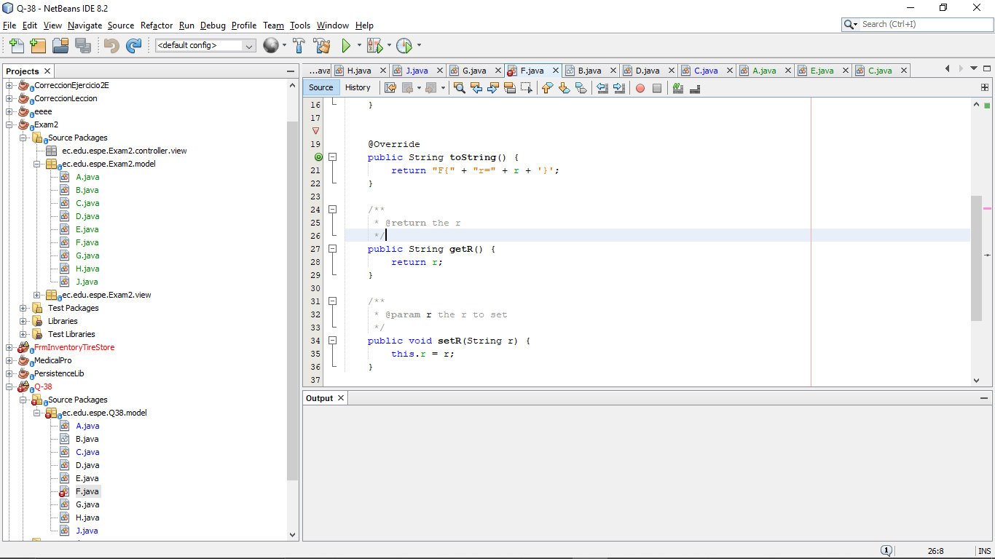

G ->implements 0.5/0.5

* + method m() /0.5

H -> interface and name 1.0/1.0

* + method m /1.0

J -> name 0.8/0.8

* + toString 0/0.2

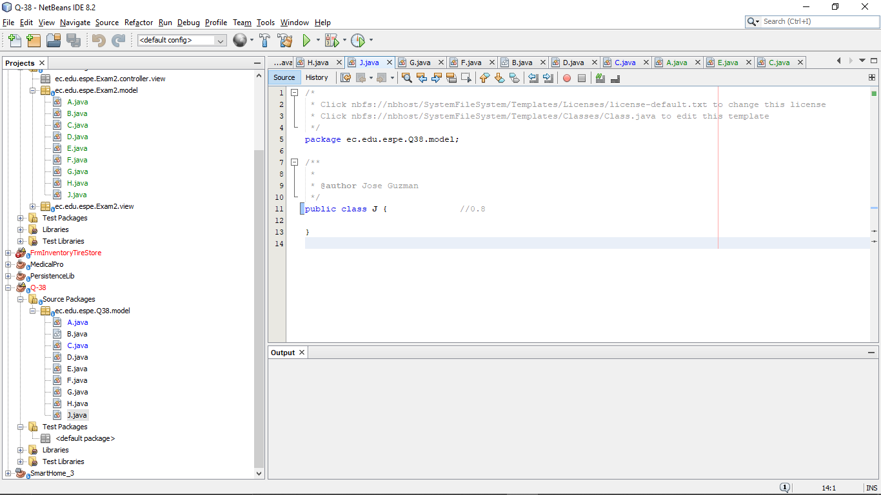

main ->

* + A a 0/0.4
  + ArrayList<B> bs 0/0.4
  + C[ ] cs = new C[3] 0/0.4
  + D[ ] ds = new D[4] 0/0.4
  + println() 0/0

Total 6.2/10 9.3/15

23 INSUASTI LOPEZ JONATHAN ESTEBA

Inspector: Mateo Landázuri

Q38-51

A ->

* + name 0.5/0.5
  + attributes 0.1/0.2
  + constructor 0.1/0.2
  + setters & getters 0.1/0.1

B ->

C ->

* + extends 0.5/0.5
  + attribute 0.2/0.2
  + constructor 0.2/0.2
  + setters & getters 0.1/0.1

D ->

* + extends 0.4/0.4
  + constructor 0.4/0.4
  + setters & getters 0.1/0.2

E ->

* + name 0.8/0.8
  + toString 0.1/0.2

F ->

* + name 0.8/0.8
  + toString 0.1/0.2

G ->

* + implements 0.2/0.5
  + method m() 0.5/0.5

H ->

* + interface and name 0.0/1.0
  + method m 1.0/1.0

J ->

* + name 0.8/0.8
  + toString 0.2/0.2

main ->

* + A a 0.1/0.4
  + ArrayList<B> bs 0.1/0.4
  + C[ ] cs = new C[3] 0/0.4
  + D[ ] ds = new D[4] 0/0.4
  + println() 0/0.4

Total 4.93/10 7.4/15

24 LANDAZURI SEGOVIA MATEO ISRAEL

Q38-51 5.6= 8.4

A ->

* + name 0.5/0.5
  + attributes 0.1/0.2
  + constructor 0.1/0.2
  + setters & getters 0.1/0.1

B ->

C ->

* + extends 0.5/0.5
  + attribute 0.2/0.2
  + constructor 0.2/0.2
  + setters & getters 0.1/0.1

D ->

* + extends 0.4/0.4
  + constructor 0.4/0.4
  + setters & getters 0.1/0.2

E ->

* + name 0.8/0.8
  + toString 0/0.2

F ->

* + name 0.8/0.8
  + toString 0/0.2

G ->

* + implements 0.1/0.5
  + method m() 0.5/0.5

H ->

* + interface and name 0.0/1.0
  + method m 1.0/1.0

J ->

* + name 0.8/0.8
  + toString 0/0.2

main ->

* + A a 0.1/0.4
  + ArrayList<B> bs 0/0.4
  + C[ ] cs = new C[3] 0/0.4
  + D[ ] ds = new D[4] 0/0.4
  + println() 0/0.4

25 LINCANGO CRIOLLO JOSE DANIEL **Total 4.1**

Inspector: Maisincho Richar

Q38-51

A ->

* + name 0.2/0.5
  + attributes 0.1/0.2
  + constructor 0.1/0.2
  + setters & getters 0/0.1

B ->

* + name 0/0.5
  + attribute 0/0.5

C ->

* + extends 04/0.5
  + attribute 0/0.2
  + constructor 0/0.2
  + setters & getters 0/0.1

D ->

* + extends 0.3/0.4
  + constructor 0.2/0.4
  + setters & getters 0/0.2

E ->

* + name 0.3/0.8
  + toString 0/0.2

F ->

* + name 0.4/0.8
  + toString 0.1/0.2

G ->

* + implements 0.4/0.5
  + method m() 0.1/0.5

H ->

* + interface and name 0/1.0
  + method m 0/1.0

J ->

* + name 0.2/0.8
  + toString 0/0.2

main ->

* + A a 0.3/0.4
  + ArrayList<B> bs 0.2/0.4
  + C[ ] cs = new C[3] 0.2/0.4
  + D[ ] ds = new D[4] 0.2/0.4
  + println() 0.2/0.4

26 MAISINCHO PAUCAR RICHAR ALEXANDER **Grade:3.8/10 → 4.3/15**

Inspector: Mateo Maldonado

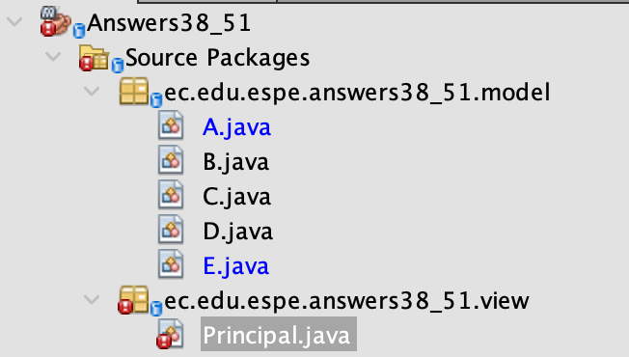

A ->

* + name 0.5/0.5
  + attributes 0/0.2
  + constructor 0/0.2
  + setters & getters 0/0.1

B ->

* + name 0.5/0.5
  + attribute 0.3/0.5

C ->

* + extends 0/0.5
  + attribute 0/0.2
  + constructor 0/0.2
  + setters & getters 0/0.1

D ->

* + extends 0/0.4
  + constructor 0/0.4
  + setters & getters 0/0.2

E ->

* + name 0.8/0.8
  + toString 0/0.2

F ->

* + name 0/0.8
  + toString 0/0.2

G ->

* + implements 0/0.5
  + method m() 0.5/0.5

H ->

* + interface and name 0/1.0
  + method m 1.0/1.0 Extra

J ->

* + name 0.5/0.8
  + toString 0/0.2

main ->

* + A a 0/0.4
  + ArrayList<B> bs 0/0.4
  + C[ ] cs = new C[3] 0.1/0.4
  + D[ ] ds = new D[4] 0.1/0.4
  + println() 0/0.4

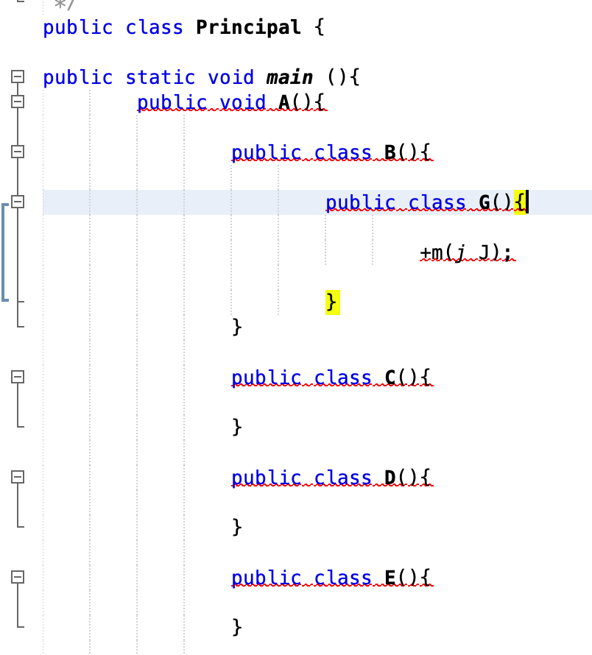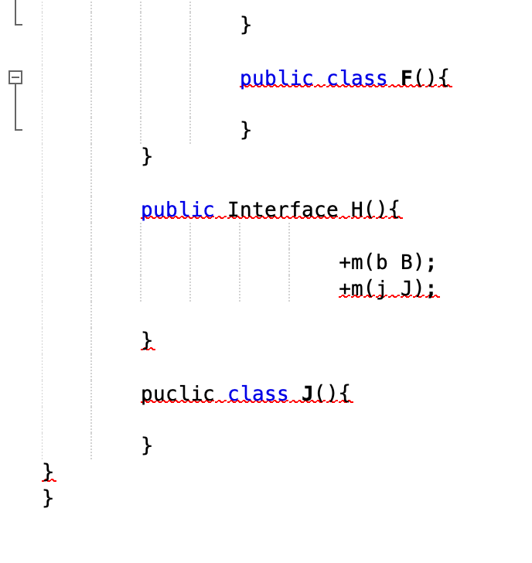

27 MALDONADO BASTIDAS MATEO STEFANO

Inspector: Leonel Mantuano

Calificación: 3.1/10 —> Grade: 2.06/15

Q38-51

A ->

* + name 0.5/0.5
  + attributes 0/0.2
  + constructor 0/0.2
  + setters & getters 0/0.1

B ->

* + name 0.5/0.5
  + attribute 0/0.5

C ->

* + extends 0.5/0.5
  + attributes 0/0.2
  + constructor 0/0.2
  + setters & getters 0/0.1

D ->

* + extends 0/0.4
  + constructor 0/0.4
  + setters & getters 0/0.2

E ->

* + name 0.8/0.8
  + toString 0/0.2

F ->

* + name 0.8/0.8
  + toString 0/0.2

G ->

* + Implements 0/0.5
  + method m() 0/0.5

H ->

* + interface and name 0/1.0
  + method m 0/1.0

J ->

* + name 0/0.8
  + toString 0/0.2

main ->

* + A a 0/0.4
  + ArrayList<B> bs 0/0.4
  + C[ ] cs = new C[3] 0/0.4
  + D[ ] ds = new D[4] 0/0.4
  + println() 0/0.4

28 MANTUANO FERNANDEZ LEONEL FERNANDO

Inspector: Anthony Morales

Grade: 1.8/10 → Grade: 1.2/15

A ->

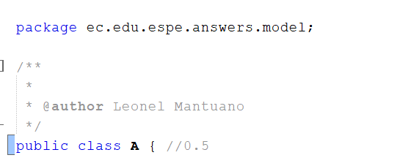

* + name 0.5/0.5
  + attributes 0/0.2
  + constructor 0/0.2
  + setters & getters 0/0.1

B ->

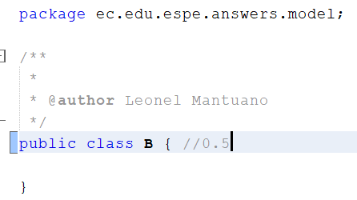

* + name 0.5/0.5
  + attribute 0/0.5

C ->

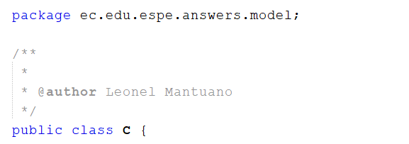

* + extends 0/0.5
  + attribute 0/0.2
  + constructor 0/0.2
  + setters & getters 0/0.1

D ->

* + extends 0/0.4
  + constructor 0/0.4
  + setters & getters 0/0.2

E ->

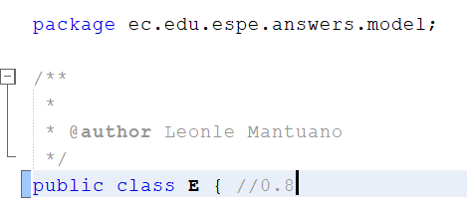

name 0.8/0.8

toString 0/0.2

F ->

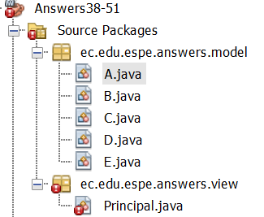

* + name 0/0.8
  + toString 0/0.2

G ->

* + implements 0/0.5
  + method m() 0/0.5

H ->



* + interface and name 0/1.0
  + method m 0/1.0

J ->



* + name 0/0.8
  + toString 0/0.2

main ->

* + A a 0/0.4
  + ArrayList<B> bs 0/0.4
  + C[ ] cs = new C[3] 0/0.4
  + D[ ] ds = new D[4] 0/0.4
  + println() 0/0.4

29 MORALES CAICEDO ANTHONY JAVIER

Inspector: Sebastian Palacios Grade 2,6/10---> 3.90/15

Q38-51

A ->

* + name 0.5/0.5
  + attributes 0/0.2
  + constructor 0/0.2
  + setters & getters 0/0.1

B ->

* + name 0.5/0.5
  + attribute 0/0.5

C ->

* + extends 0/0.5
  + attribute 0/0.2
  + constructor 0/0.2
  + setters & getters 0/0.1

D ->

* + extends 0/0.4
  + constructor 0/0.4
  + setters & getters 0/0.2

E ->

* + name 0/0.8
  + toString 0/0.2

E->

* + name 0.8/0.8
  + toString 0/0.2

F ->

* + name 0.8/0.8
  + toString 0/0.2

G ->

* + Implements 0/0.5
  + method m() 0/0.5

H ->

* + interface and name 0/1.0
  + method m 0/1.0

J ->

* + name 0/0.8
  + toString 0/0.2

main ->

* + A a 0/0.4
  + ArrayList<B> bs 0/0.4
  + C[ ] cs = new C[3] 0/0.4
  + D[ ] ds = new D[4] 0/0.4
  + println() 0/0.4

30 PALACIOS CANDO DIEGO SEBASTIAN

Inspector: Javier Paucar

Q38-51 0

31 PAUCAR LEMA ALEX JAVIER Total: 5.8/10 -> 8.7/15

Inspector : Quinga Leandro

Q38-51

A ->

* + name 0.5/0.5
  + attributes 0/0.2
  + constructor 0/0.2
  + setters & getters 0/0.1

B ->

* + name 0.5/0.5
  + attribute 0/0.5

C ->

* + extends 0.5/0.5
  + attribute 0/0.2
  + constructor 0/0.2
  + setters & getters 0/0.1

D ->

* + extends 0.4/0.4
  + constructor /0.4
  + setters & getters /0.2

E ->

name 0.8/0.8

toString 0/0.2

F ->

* + name 0.8/0.8
  + toString /0.2

G ->

* + implements 0.5/0.5
  + attribute /0.2

H ->

* + interface and name 1/1.0
  + method m /1.0

J ->

* + name 0.8/0.8
  + toString 0/0.2

main ->

* + A a 0/0.4
  + ArrayList<B> bs 0/0.4
  + C[ ] cs = new C[3] 0/0.4
  + D[ ] ds = new D[4] 0/0.4
  + println() 0/0.4

32 QUINGA GUAYASAMIN LEANDRO ALEXANDER Total: 6,2/10 —---> 9.3/15

inspector: Alexander Ruano

Q38-51

A ->

* + name 0.5/0.5
  + attributes 0/0.2
  + constructor 0/0.2
  + setters & getters 0/0.1

B ->

* + name 0.5/0.5
  + attribute /0.5

C ->

* + extends 0.5/0.5
  + attribute 0/0.2
  + constructor 0/0.2
  + setters & getters 0/0.1

D ->

* + extends 0.4/0.4
  + constructor 0/0.4
  + setters & getters 0/0.2

E ->

* + name 0.8/0.8
  + toString 0/0.2

F ->

* + name 0.8/0.8
  + toString /0.2

G ->

* + implements 0.5/0.5
  + method m() /0.5

H ->

* + interface and name 1/1.0
  + method m /1.0

J ->

* + name 0.8/0.8
  + toString 0/0.2

main ->

* + A a 0.4/0.4
  + ArrayList<B> bs 0/0.4
  + C[ ] cs = new C[3] 0/0.4
  + D[ ] ds = new D[4] 0/0.4
  + println() 0/0.4

33 RUANO PONCE ALEXANDER JAVIER Total:5.8/10 ->8.7/15

Inspector :Paul Saltos

Q38-51

A ->

* + name 0.5/0.5
  + attributes 0/0.2
  + constructor 0/0.2
  + setters & getters 0/0.1

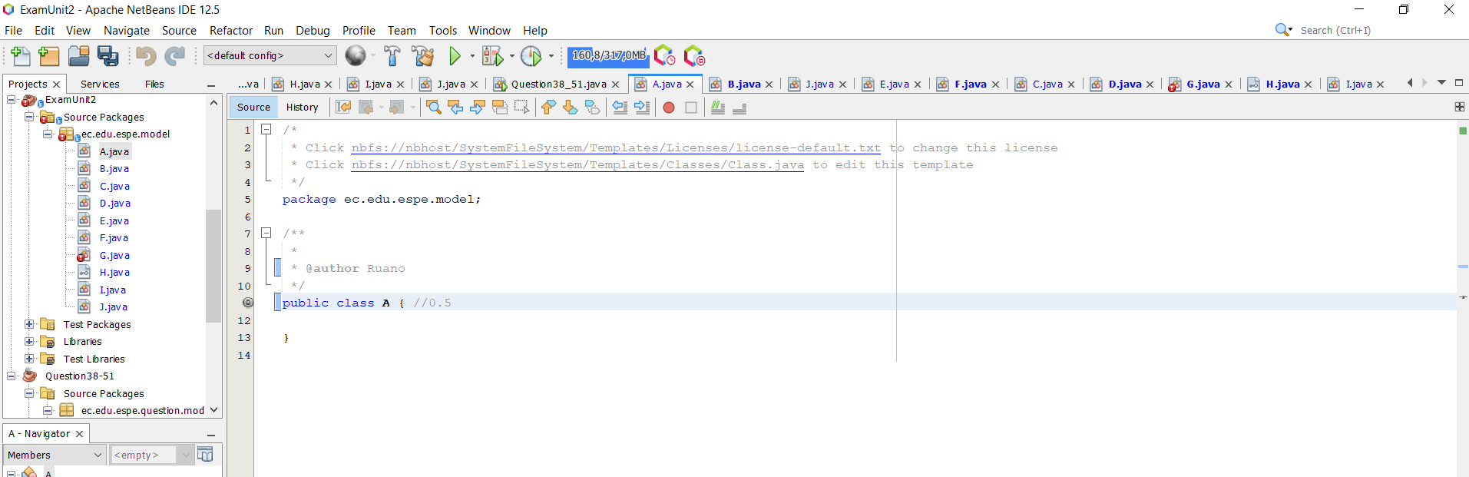

B ->

* + name 0.5/0.5
  + attribute 0/0.5

C ->

* + extends 0.5/0.5
  + attribute 0/0.2
  + constructor 0/0.2
  + setters & getters 0/0.1

D ->

* + extends 0.4/0.4
  + constructor 0/0.4
  + setters & getters 0/0.2

E ->

name 0.8/0.8

toString 0/0.2

F ->

* + name 0.8/0.8
  + toString 0/0.2

G ->

* + implements 0.5/0.5
  + method m() 0/0.5

H ->

* + interface and name 1.0/1.0
  + method m 0/1.0

J ->

* + name 0.8/0.8
  + toString 0/0.2

main ->

* + A a 0/0.4
  + ArrayList<B> bs 0/0.4
  + C[ ] cs = new C[3] 0/0.4
  + D[ ] ds = new D[4] 0/0.4
  + println() 0/0.4

34 SALTOS TACO PAUL ALEXANDER TOTAL 6.2/10 9,3/15

Inspector: Sanchez Jose

Q38-51

A ->

* + name 0.5/0.5
  + attributes 02./0.2
  + constructor 0.2/0.2
  + setters & getters 0.1/0.1

B ->

* + name 0.5/0.5
  + attribute /0.5

C ->

* + extends 0.5/0.5
  + attribute /0.2
  + constructor /0.2
  + setters & getters /0.1

D ->

* + extends 0.4/0.4
  + constructor /0.4
  + setters & getters /0.2

E ->

name 0.8/0.8

toString /0.2

F ->

* + name 0.8/0.8
  + toString /0.2

G ->

* + implements 0.5/0.5
  + method m() 0/0.5

H ->

* + interface and name 1.0/1.0
  + method m /1.0

J ->

* + name 0.8/0.8
  + toString 0/0.2

main ->

* + A a 0.4/0.4
  + ArrayList<B> bs 0/0.4
  + C[ ] cs = new C[3] 0/0.4
  + D[ ] ds = new D[4] 0/0.4
  + println() 0/0.4

35 SANCHEZ MISHQUERO JOSE FRANCISCO TOTAL.7..2--10 10.8/15

inspector: Alan Shuguli

Q38-51

A ->

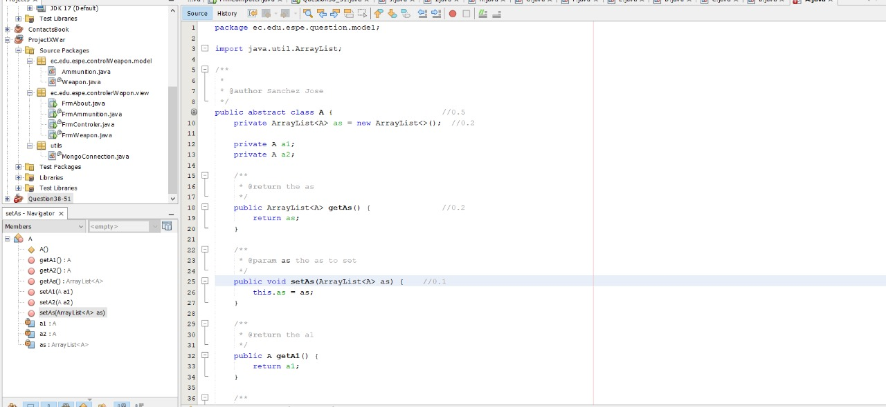

* + name 0.5/0.5
  + attributes 0.2/0.2
  + constructor 0.2/0.2
  + setters & getters 0.1/0.1

B ->

* + name 0.5/0.5
  + attribute /0.5

C ->

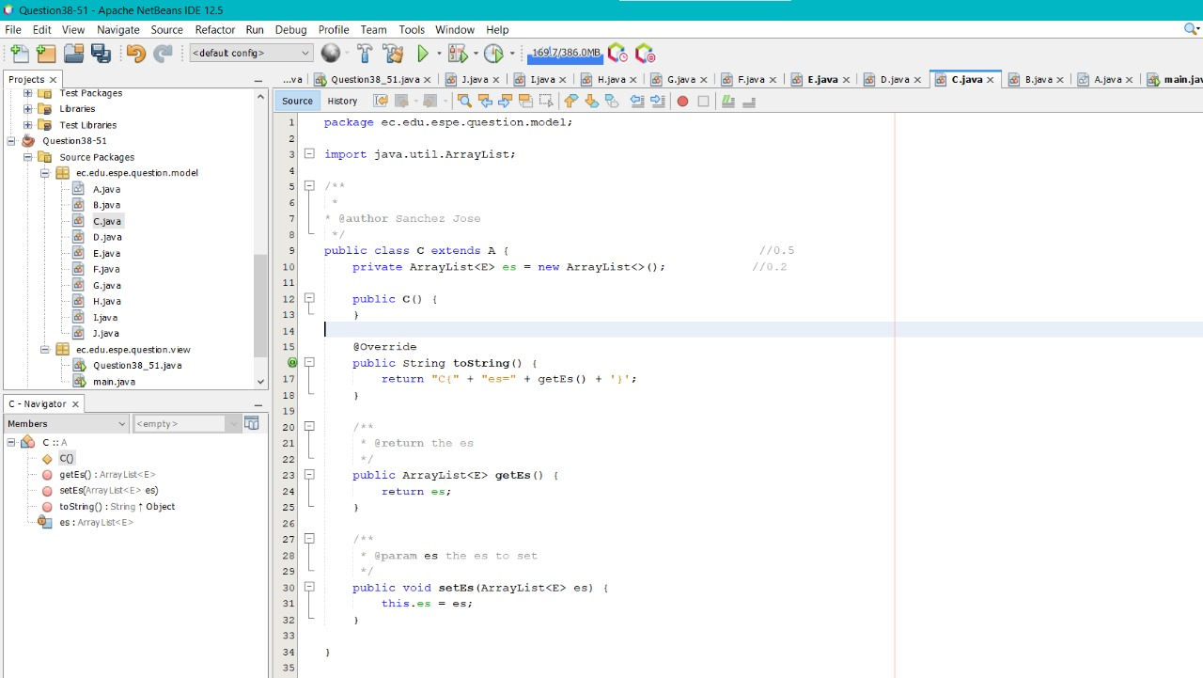

* + extends 0.5/0.5
  + attribute 0.2/0.2
  + constructor 0.2/0.2
  + setters & getters 0.1/0.1

D ->

* + extends 0.4/0.4
  + constructor 0.4/0.4
  + setters & getters 0/0.2

E ->

name 0.8/0.8

toString 0.2/0.2

F ->

* + name 0.8/0.8
  + toString 0.2/0.2

G ->

* + implements 0.5/0.5
  + method m() 0/0.5

H ->

* + interface and name 1.0/1.0
  + method m 0/1.0

H ->

* + interface and name 1/1.0
  + method m 0/1.0

J ->

* + name 0.8/0.8
  + toString 0.2/0.2

main ->

* + A a 0.4/0.4
  + ArrayList<B> bs 0/0.4
  + C[ ] cs = new C[3] 0/0.4
  + D[ ] ds = new D[4] 0/0.4
  + println() 0/0.4

36 SHUGULI REINOSO ALAN JESITH Total 4/10 6/15

Inspector: Jontahan Simbaña

A ->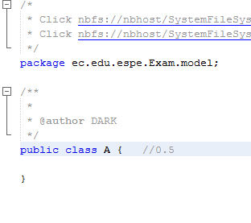

* + name 0.5/0.5
  + attributes 0/0.2
  + constructor 0/0.2
  + setters & getters 0/0.1

B ->

* + name 0.5/0.5
  + attribute 0/0.5

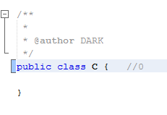

C ->

* + extends 0.2/0.5
  + attribute 0/0.2
  + constructor 0/0.2
  + setters & getters 0/0.1

D ->

* Name 0.2/0.4
* Attributes 0.0/0.4
* Setters & getters 0.0/0.2

Total 0.0/1

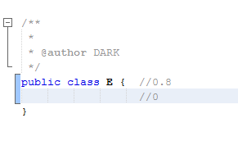

E ->

name 0.8/0.8

toString /0.2

F ->

* + name 0.8/0.8
  + toString 0/0.2

G ->

* + implements 0/0.5
  + method m() 0/0.5

H ->

interface and name 1.0/1.0

* + method m 0/1.0

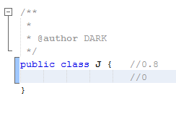

J ->

* + name 0.8/0.8
  + toString 0/0.2

main ->

* + A a 0/0.4
  + ArrayList<B> bs 0/0.4
  + C[ ] cs = new C[3] 0/0.4
  + D[ ] ds = new D[4] 0/0.4
  + println() 0/0.4

37 SIMBAÑA SIMBAÑA JONATHAN GUSTAVO 5/10 -> 7.5/15

Inspector: Andrea Tapia

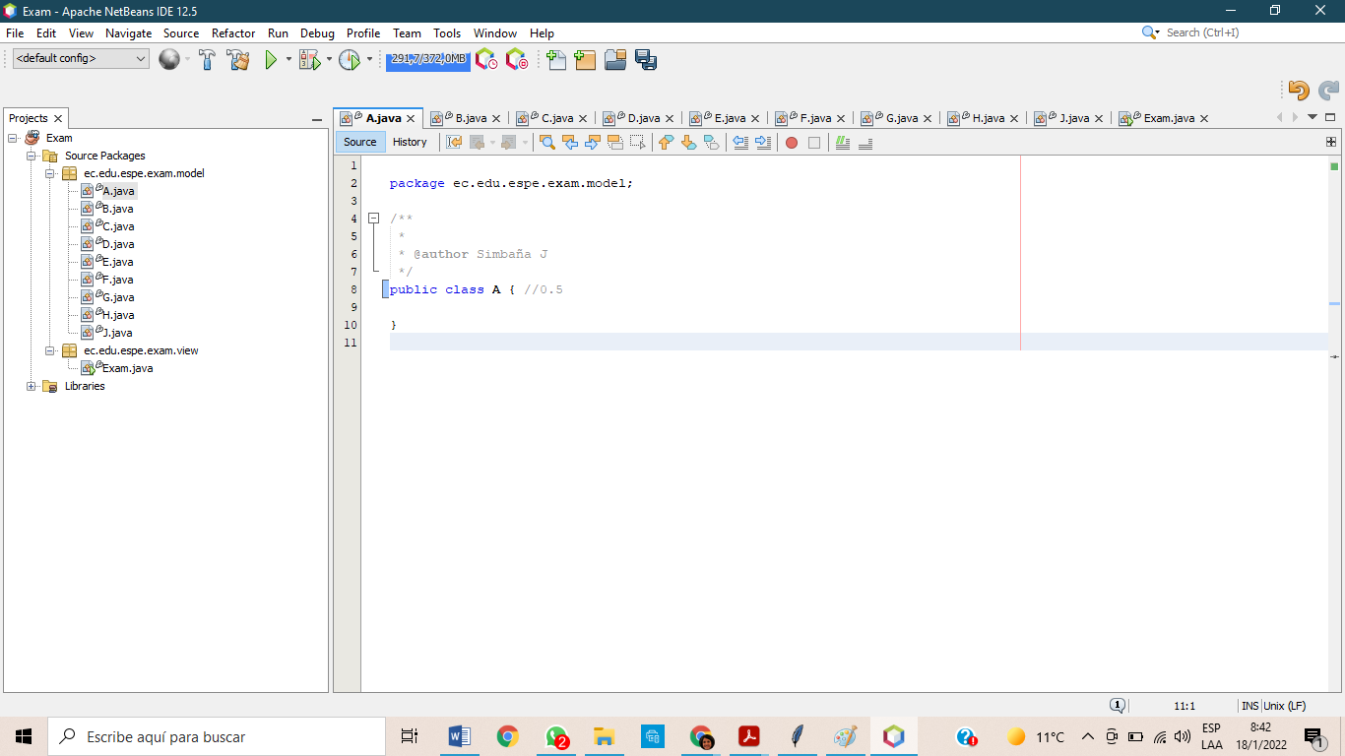

A ->

* + name 0.5/0.5
  + attributes /0.2
  + constructor /0.2
  + setters & getters /0.1

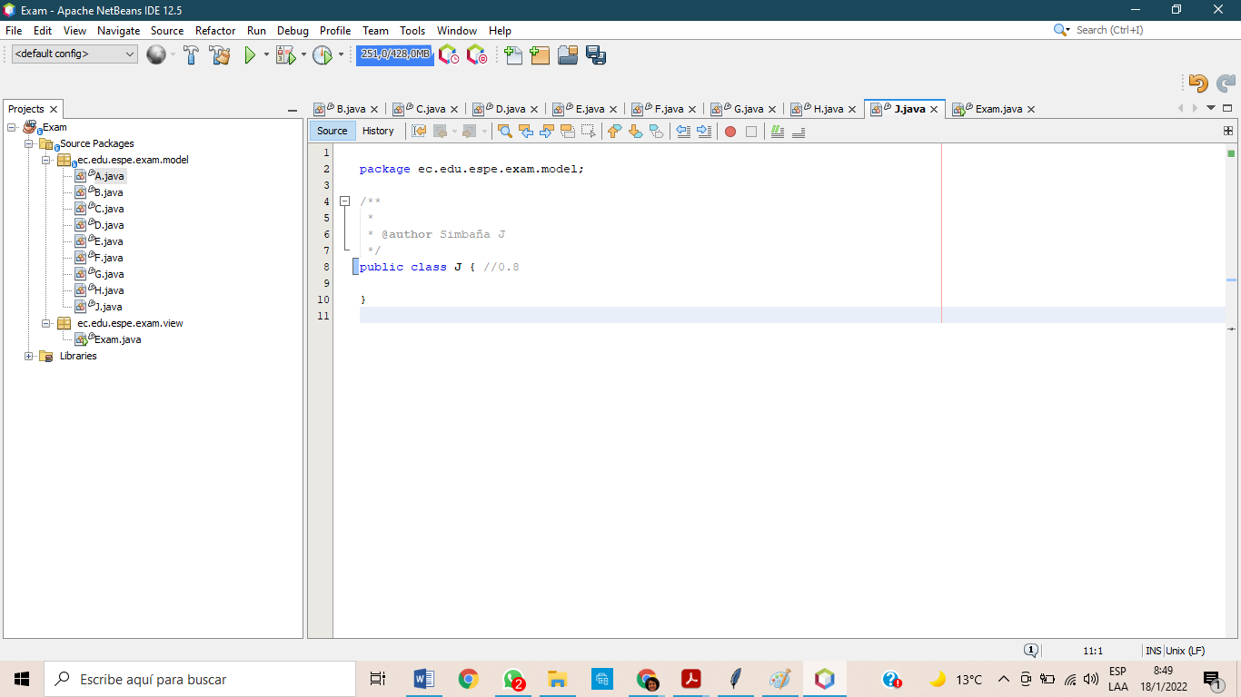

J ->

* + name 0.8/0.8
  + toString /0.2

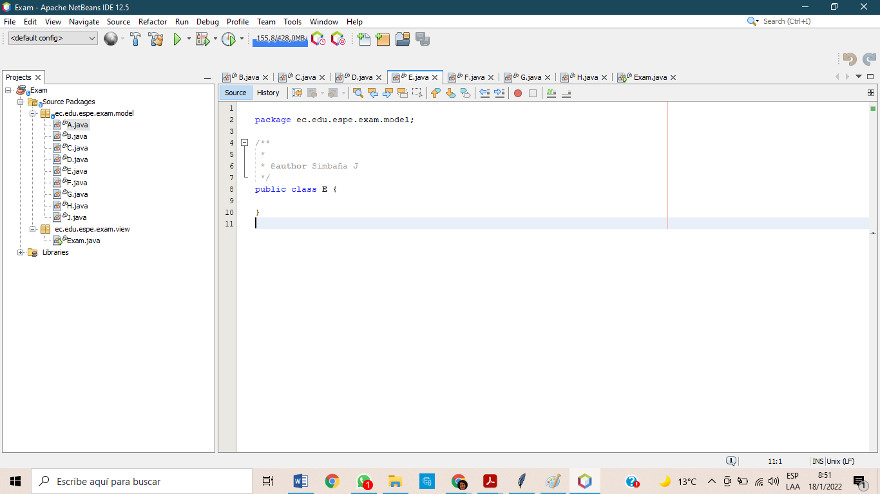

E ->

* name 0.8 /0.8
* toString /0.2

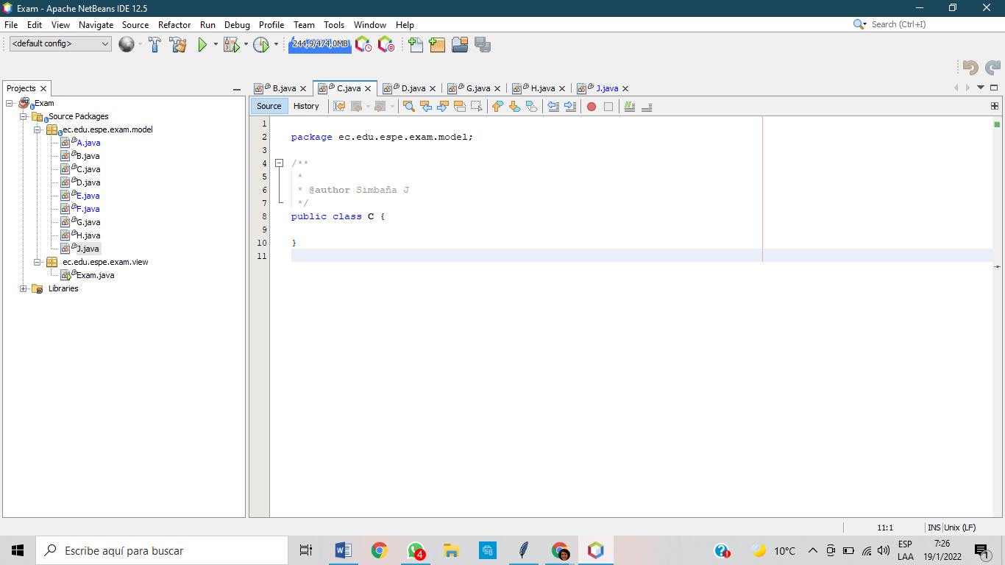

C ->

* extends 0.2/0.5
* attribute 0/0.2
* constructor 0/0.2
* setters & getters 0/0.1

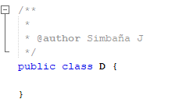

D ->

* extends 0.2/0.4
* constructor 0/0.4
* setters & getters 0/0.2

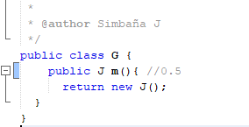

G ->

* implements 0.2/0.5
* method m() 0.5/0.5

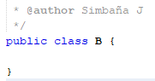

B ->

* name 0.5/0.5
* attribute 0/0.5

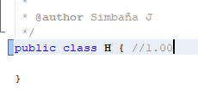

H->

* interface and name 0.5/1.0
* method m 0/1.0

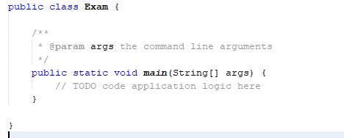

main ->

* + A a 0/0.4
  + ArrayList<B> bs 0/0.4
  + C[ ] cs = new C[3] 0/0.4
  + D[ ] ds = new D[4] 0/0.4
  + println() 0/0.4

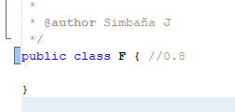

F ->

* + name 0.8/0.8
  + toString /0.2

38 TAPIA ALBAN ANDREA JULIANNA Total: 8.2/10 -> 12.3/15

inspector: Sebastian Tayo

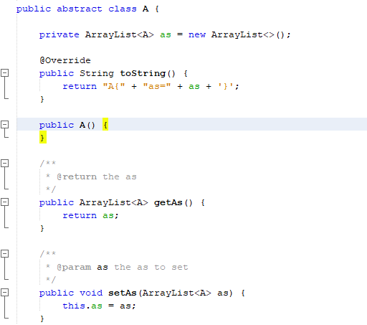

A ->

* name 0.5/0.5
* attributes 0.2/0.2
* constructor 0.2/0.2
* setters & getters 0.1/0.1

Total 1/1

B ->

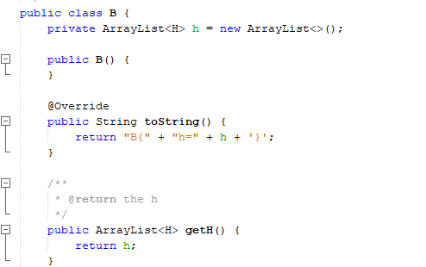

* name 0.5/0.5
* attribute 0.3/0.5

total 0.8/1

C ->

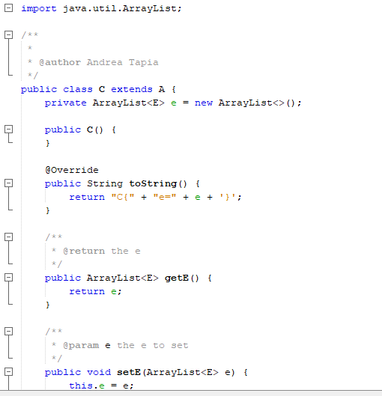

* name 0.5/0.5
* attributes 0.2/0.2
* constructor 0.2/0.2
* setters & getters 0.1/0.1

Total 1/1

D ->

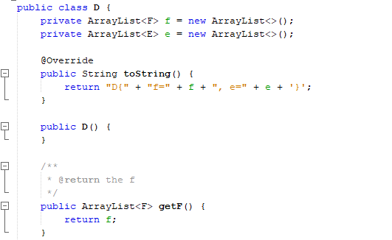

* Name 0.4/0.4
* Attributes 0.2/0.4
* Setters & getters 0.2/0.2

Total 0.8/1

E ->

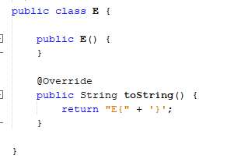

* name 0.8/0.8
* to String 0.2/0.2

Total 1/1

F ->

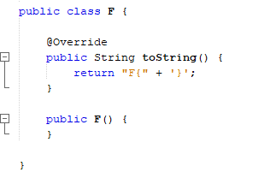

* name 0.8/0.8
* to String 0.2/0.2

Total 1/1

G ->

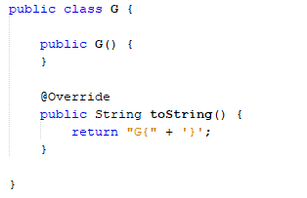

* implements 0.2/0.5
* method m() 0/0.5

total 0.2/1

H ->

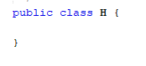

* interface and name 1.0/1.0
* method m 0/1.0

Total 1/1

J ->

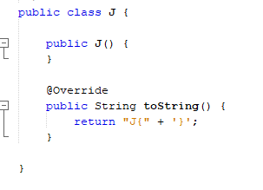

* name 0.8/0.8
* to String 0.2/0.2

Total 1/1

main ->

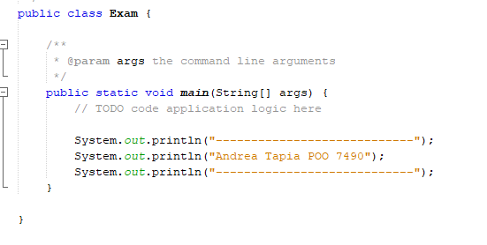

* + A a /0.4
  + ArrayList<B> bs /0.4
  + C[ ] cs = new C[3] /0.4
  + D[ ] ds = new D[4] /0.4
  + println() 0.4/0.4

Total 0.4/2

39 TAYO RUIZ SEBASTIAN ALEJANDRO

Inspector: Camila Teca Grade : 5.3 /10 -> 7.95/15

Q38-51

A ->

* + name 0.5/0.5
  + attributes 0/0.2
  + constructor 0/0.2
  + setters & getters 0/0.1

B ->

* + name 0.5/0.5
  + attribute 0/0.5

C ->

* + extends 0/0.5
  + attribute 0/0.2
  + constructor 0/0.2
  + setters & getters 0/0.1

D ->

extends 0.4/0.4

* + constructor 0/0.4
  + setters & getters 0/0.2

E ->

* + name 0.8/0.8
  + toString 0/0.2

F ->

* + name 0.8/0.8
  + toString 0/0.2

G ->

* + implements 0.5/0.5
  + method m() 0/0.5

H ->

interface and name 1.0/1.0

* + method m 0/1.0

J ->

* + name 0.8/0.8
  + toString 0/0.2

main ->

* + A a 0/0.4
  + ArrayList<B> bs 0/0.4
  + C[ ] cs = new C[3] 0/0.4
  + D[ ] ds = new D[4] 0/0.4
  + println() 0/0.4

CLASS A:

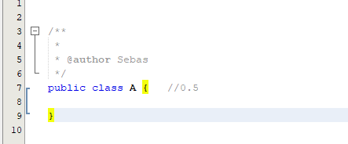

CLASS J:

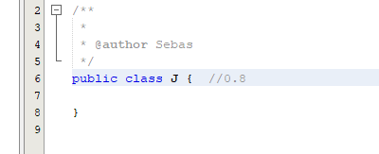

CLASS E:

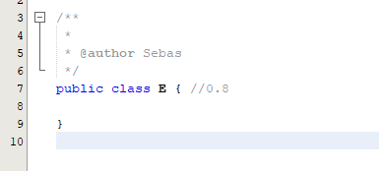

CLASS F:

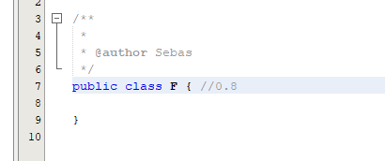

CLASS C:

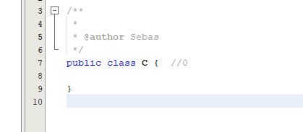

CLASS D:

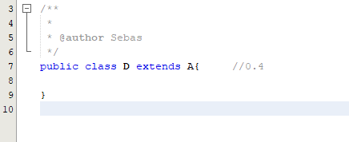

CLASS H:

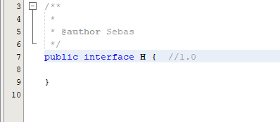

CLASS G:

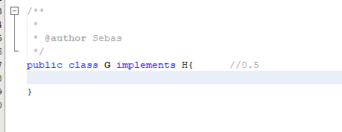

CLASS B:

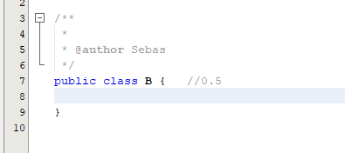

MAIN:

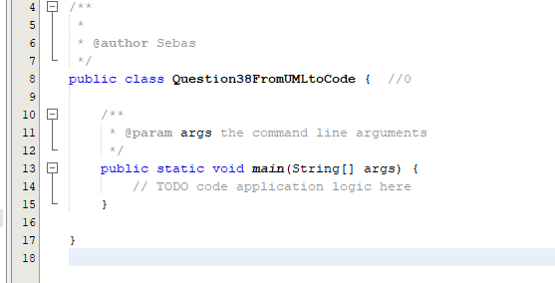

40 TECA TELLO CAMILA MILENA

Inspector: Melanie Terán

Grade: 5.9/10 -> 8.85/15

A ->

* + name 0.5/0.5
  + attributes 0/0.2
  + constructor 0/0.2
  + setters & getters 0/0.1

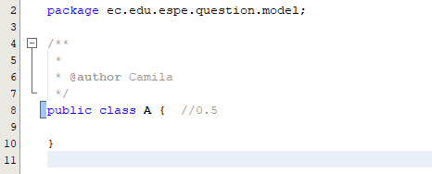

B ->

* + name 0.5/0.5
  + attribute 0.5/0.5

C ->

* + extends 0/0.5
  + attribute 0/0.2
  + constructor 0/0.2
  + setters & getters 0/0.1

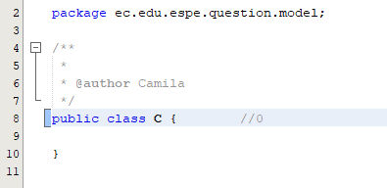

D ->

* + extends 0/0.4
  + constructor 0/0.4
  + setters & getters 0/0.2

E ->

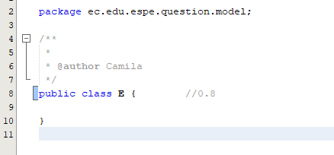

* name 0.8/0.8
* toString 0/0.2

F ->

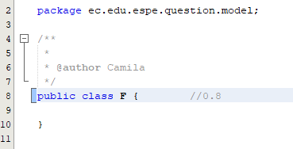

* name 0.8/0.8
* toString 0/0.2

G ->

* implements 0.5/0.5
* method m() 0.5/0.5

H ->

* interface and name 1.0/1.0
* method m 0/1.0

J ->

* name 0.8/0.8
* toString 0/0.2

main ->

* A a 0/0.4
* ArrayList<B> bs 0/0.4
* C[ ] cs = new C[3] 0/0.4
* D[ ] ds = new D[4] 0/0.4
* println() 0/0.4

41 TERAN FLORES MELANIE ELIZABETH

Inspector: Salma Villegas

Q38-51

A -> 0.7

* + name 0.5/0.5
  + attributes 0.2/0.2
  + constructor 0/0
  + setters & getters 0/0

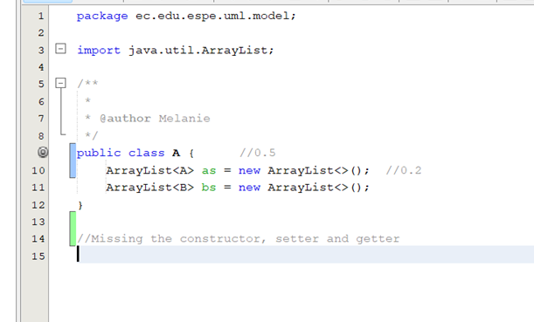

B -> 0.5

* + name 0.5/0.5
  + attribute 0/0.5

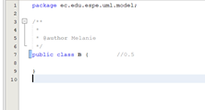

C -> 0.7

extends 0.5/0.5

* + attribute 0.2/0.2
  + constructor 0/0.2
  + setters & getters 0/0.1

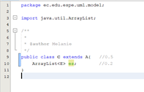

D -> 0.4

* + extends 0.4/0.4
  + constructor 0/0.4
  + setters & getters 0/0.2

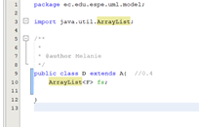

E -> 0.8

name 0.8/0.8

toString 0/0.2

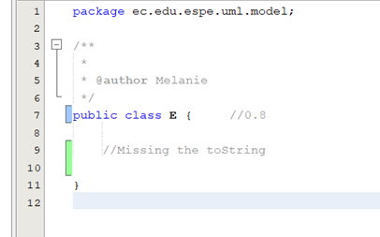

F -> 0.8

name 0.8/0.8

* + toString 0/0.2

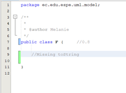

G -> 1.00

* + implements 0.5/0.5
  + method m() 0.5/0.5

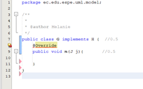

H -> 1.0

* + interface and name 1.0/1.0
  + method m 0/1.0

J -> 0.8

* + name 0.8/0.8
  + toString 0/0

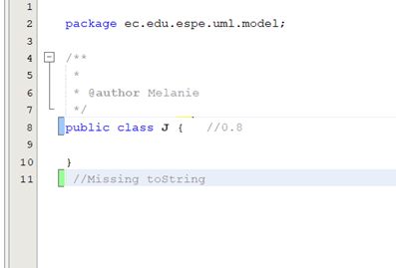

main -> 1.00

* + A a 0.4/0.4
  + ArrayList<B> bs 0.4/0.4
  + C[ ] cs = new C[3] /0.4
  + D[ ] ds = new D[4] /0.4
  + println() 0.2/0.4

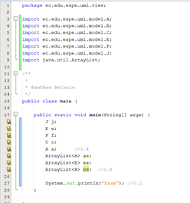

**Total: 7.5/10 11.25/15**

42 VILLEGAS ESTRELLA SALMA ABIGAIL

Inspector: Joel Zeas

Q38-51

A ->

* + name 0.5/0.5
  + attributes 0/0.2
  + constructor 0/0.2
  + setters & getters 0.1/0.1

B ->

* + name 0.5/0.5
  + attribute 0/0.5

C ->

* + extends 0.5/0.5
  + attribute 0/0.2
  + constructor 0/0.2
  + setters & getters 0.1/0.1

D ->

* + extends 0.4/0.4
  + constructor 0/0.4
  + setters & getters 0.2/0.2

E ->

name 0.8/0.8

toString 0/0.2

F ->

* + name 0.8/0.8
  + toString 0/0.2

G ->

* + implements 0.5/0.5
  + method m() 0/0.5

H ->

* + interface and name 0/1.0
  + method m 0/1.0

J ->

* + name 0.8/0.8
  + toString 0.2/0.2

main ->

* + A a 0.4/0.4
  + ArrayList<B> bs 0/0.4
  + C[ ] cs = new C[3] 0/0.4
  + D[ ] ds = new D[4] 0/0.4
  + println() 0.4/0.4

**Total: 6.20 9.30/15**

43 ZEAS CLAVIJO JOEL ALEXANDER

Inspector: Anderson Almache

A ->

• name 0.5/0.5

• attributes 0/0.2

• constructor 0/0.2

• setters & getters 0.1/0.1

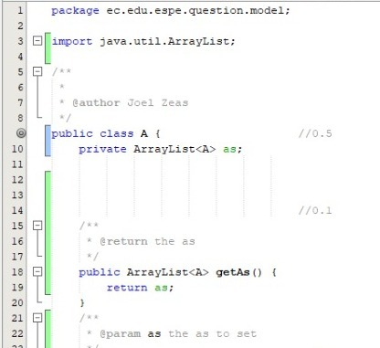

B ->

• name 0.5/0.5

• attribute 0/0.5

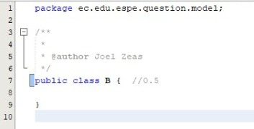

C ->

• extends 0.5/0.5

• attribute 0/0.2

• constructor 0/0.2

• setters & getters 0.1/0.1

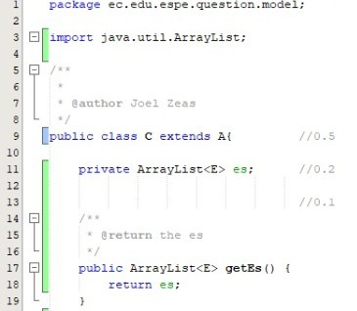

D ->

• extends 0.4/0.4

• constructor 0/0.4

• setters & getters 0.2/0.2

E ->

name 0.8/0.8

toString 0/0.2

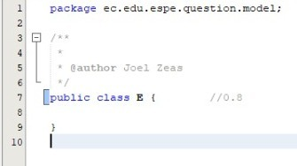

F ->

• name 0.8/0.8

• toString 0.2/0.2

G ->

• implements 0.5/0.5

• method m() 0.1/0.5

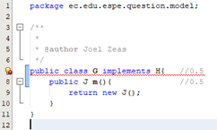

H ->

• interface and name /1.0

• method m /1.0

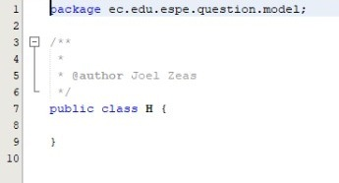

J ->

• name 0.8/0.8

• toString 0.2/0.2

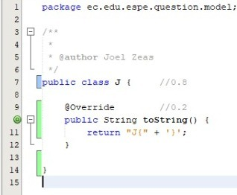

main ->

• A a 0.4/0.4

• ArrayList<B> bs 0.4/0.4

• C[ ] cs = new C[3] 0/0.4

• D[ ] ds = new D[4] 0/0.4

• println() 0/0.4

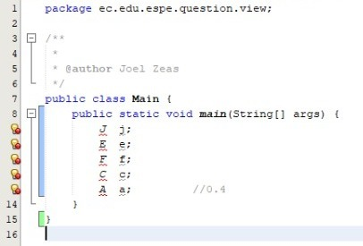

**Total: 6.4/10 9.6/15**